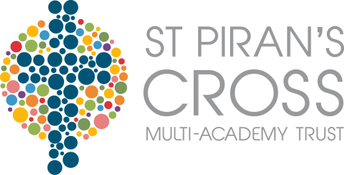
Piran’s Cross CofE Multi-Academy Trust
Office 38, Victoria Commercial Centre
Station Approach
Victoria
Roche
Cornwall
PL26 8LG
T: 01726 250260
E: enquiries@stpiranscross.co.uk

March 27th 2017

Dear Parents,
In the continued spirit of openness and transparency, we agreed that we would keep you fully up to date with developments for September 2017 at Veryan Primary School.
It is with mixed emotions that I am writing to inform you of one more staff change for September. Mrs Sophie Greenaway has been appointed as the new Assistant Head of School at Bishop Bronescombe CE Primary in St Austell after extensive interviews.
This is a huge achievement and success for Sophie and I am sure you would want to join us in congratulating her on this appointment. She has grown as a school leader at Veryan and will be greatly missed.
As you know, we are currently recruiting new teachers for September and I am pleased to tell you that we have made two outstanding appointments this week:
- Mrs Jayne Coley will be teaching Nursery, Reception and Year 1 during the mornings. Jayne is very well known to you all and the community of Veryan and brings a wealth of experience.
- Miss Laura Blayney has been appointed to teach the Year 2, 3 and 4 class. Laura has recently completed a successful teaching practice at Veryan and comes highly recommended from her professional referees and more importantly from the children in Kiberick Class who thought she was wonderful!
There will be an opportunity to meet these new staff later next term.
The Head of Veryan School interviews are planned for 5th May and we have had lots of interest in this post from some clearly strong and capable candidates.

We will both continue to keep you briefed on the developments at school and be reassured that it is our quest to ensure that the very best staff are working with your children in September 2017.
We are both accompanying the Year 5 residential to London from Wednesday to Friday but will be available to discuss concerns early next term.
With best wishes for your Easter holidays,
Yours sincerely
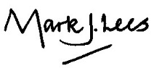
Mark Lees Lisa Michell
Executive Principal Acting Headteacher

