Veryan Primary School News
Friday 11th March 2016
Talk Topic –
Christian Values Challenge
Think of a number…
Ask yourself and family and friends “How many ways can this number be made?”

SPRING TERM 2016 DATES

Dates for diaries:
14th March – Cornwall Music Festival
15th March – Girls Football Match, Tregony
16th March - Parent Forum
17th March – Centenary Shield Match
18th March – SAT paper orders (see overleaf)
21st March – Annual Reports sent to parents
21st March Roseland TAG Rugby Festival
24th March – Last day of the spring term
11th April - New term begins
Our Student of the Week for Numeracy
Carne class is: Sylvie Trounce
Pendower class is: Archie Tullett
Kiberick class is: Eddie Brickell

Our Achievers of the Week are:
Carne class: William Wilson & Rory Beetham
Pendower class: Rose Kendle & Daraka Smith
Kiberick class: Hebby Shreck & Eve Riley

Well done to you all for your hard work!

Attendance
The expected average percentage attendance for a child is 95%.
Last week the attendance level of each class was:
- Carne Class – 81.7%
- Pendower Class – 95.7%
- Kiberick Class – 98.4%

Parent texting service.
Thank you for all the responses regarding the Teachers2Parent texts. Some parents/carers have requested that the texts are sent to more than one mobile number. It is possible that we may be able to do this in future and are negotiating with Teachers2Parents to enable this service.
Parent Forum - Wednesday 16thMarch 2016 at 6 pm.
We are now providing the opportunity for all parents to come into school and discuss issues, pleasures and concerns on a half termly basis with me. It is not the opportunity to discuss your own child, as this should be addressed to the class teacher in the first instance. The next of these meetings takes place in Kiberick 2 on: Wednesday 16th March.

I hope that lots of you will attend! There is no agenda, you will set it! We will be providing tea and coffee as well. Please bring toys for your pre-school children to play with.
Mr Lees and I will look forward to seeing you

Celebrations
Many happy returns to Red Shreck,
have a wonderful birthday!

Weekly food orders
Thank you to all parents/carers for your pre-orders and weekly menu choices. Ordering lunches in this way has given more time over to teaching and learning in the classrooms each morning.

We will be having an exciting new menu from Chartwells after the Easter break so a new order sheet will be sent home. Again, this can be completed with your child and kept at school on a weekly cycle, or if you prefer to choose on a weekly basis please remember to complete and hand in your choices at the school office/post box.

If you haven’t already handed in your advance food orders please can we remind you to return your weekly order slip (Week 1. 14th March) on Monday morning.
Proud Moments We had another exciting week last week with both the BIG SING at Truro Cathedral and World Book Day. The children and staff had a wonderful experience at both of these events and we wanted to share some more of our photographs with you all…
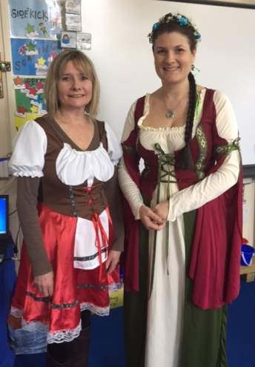

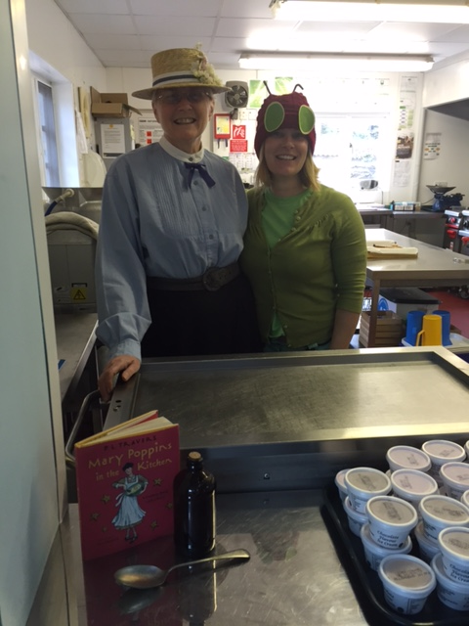

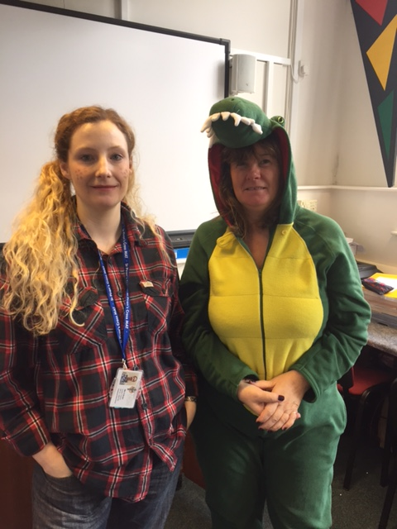
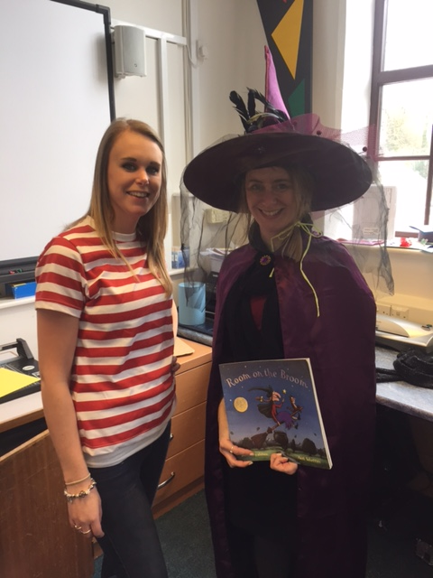

.

SAT’s Exam papers
Thank you to those parents/carers who have already responded to the offer letter sent out this week for the Ninja Exam practice SAT papers. The deadline for ordering the papers is Friday 18th March. We hope to be able to place the order and receive the papers for distribution before the Easter break.

Cornwall Music Festival – reminder!
Please would all parents return their consent forms and/or decline slips to the office tomorrow morning (Friday) ready for the trip on Monday 14th March.
Thank you for the replies received so far – it looks set to be quite an event!

Parent appointments
We are always more than happy to talk to parents/carers about any aspect of their child’s progress and share information/answer questions or queries. As you can appreciate the teacher’s morning is very busy preparing for lessons and ensuring the classroom is ready for the days learning, so we would like to ask that where possible, an appointment is made if you need to speak to the class teacher.

Easter Egg Hunt
Easter Monday
Veryan sports and social club
11am. £2 to hunt
Refreshments and Teddybear Tombola
Any good quality teddy bears and soft toys needed for the teddy bear tombola. Please give to Olivia Lobb

.

