St Piran’s Cross CofE Multi-Academy Trust
Office 38, Victoria Commercial Centre
Station Approach
Victoria
Roche
Cornwall
PL26 8LG
T: 01726 250260
E: enquiries@stpiranscross.co.uk
March 23rd 2017
Dear Year 5 Parents,
London Residential – 29th to 31st March 2017
I am writing to let you know that we are currently taking advice on the safety of travel to London next week following the terrible terrorist incidents in London on Wednesday.
Our thoughts and prayers are with the victims and we are very aware that you will be understandably concerned about this.
Today I will be contacting The Education Visits Coordinator at Cornwall Council, The Travel Company that has organised our visit to London and the Department for Education in London for advice on our pending trip to the capital city.
Once we have considered all of this advice, we will write to you again before the weekend with an update on our proposed travel plans.
Please be reassured that the care and safety of our children is of paramount importance to us.
With best wishes,
Yours sincerely,
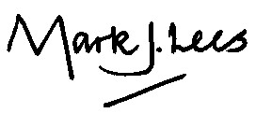
Mark Lees
Executive Principal

