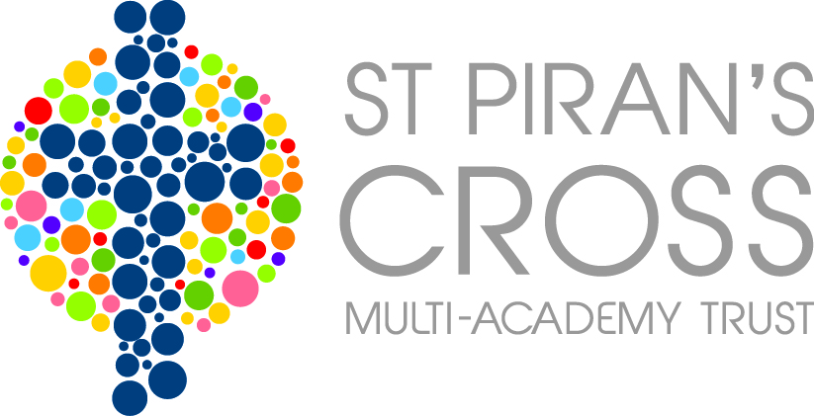
St Piran’s Cross C of E Multi-Academy Trust
Pupil Premium Report – Veryan
Report Period 1st September 2014- 31st August 2015
This funding was received after conversion to a Multi-Academy Trust during the grant period 2014/2015 and 2015/2016.
PPG provides funding for two policies:
• Raising the attainment of disadvantaged pupils and closing the gap with their peers; and
• Supporting children and young people with parents in the regular armed forces

The period of reporting spans over two different grant allocations. Please see information below.

Pupil Premium Grant (PPG) Received
1st September 2014- 31st August 2015
Funding carried forward from previous period |  | £0
Total amount of funding received in this period |  | £17326
Total amount of funding received |  | £17326
Nature of Support 1st December 2014- 31st August 2015 and allocation of PPG | Amount | Impact Statement
Jane Palmer | £2113.23 | Appointing a Pupil Premium coordinator enabled us to have a representative at briefing meetings and keep abreast of the latest developments regarding Pupil premium funding. This, in turn, enhanced our provision by giving us fresh ideas of interventions which might support the learning of our Pupil Premium children.  The coordinators role also enabled the close tracking of our Pupil Premium children’s attainment and progress so that under performance could be addressed and the impact of interventions be monitored. The coordinator also met with the Pupil Premium children and their parents so that in depth discussions could take place to work out what would support each child on an individual basis.
TAs interventions including Breakfast Club | £14195.47 | TA Intervention:  Average points progress for the 2014/15 academic year for Pupil Premium children compared to non Pupil premium children was as follows (where 3 points progress is expected)  Reading Writing Maths  PP Non PP PP Non PP PP Non PP  3 4 4.3 4 4.3 6 4  4 3 3.3 4 4.3 4 2.8  5 2.7 3.2 2 2 5.3 5.5  6 2.6 2.9 3.1 3.5 4.3 4.5  This shows that in most year groups, children eligible for Pupil premium funding have made about the same (or more) progress than non Pupil premium children. All PP children in all year groups made more than expected progress in reading, writing and maths (except in year 5 and 6 reading which was slightly below)  TAs are able to support the learning within class as well as taking individual and small groups for intervention. Pre-teaching also takes place. which is reflected in the good progress.  Breakfast Club:  This good progress also reflects that those children attending Breakfast Club start the school day with a healthy breakfast in a calm, settled manner ready to start the day’s learning. During breakfast club, homework is supported as well as areas of learning that these children find difficult.
Cool milk | £69.30 | Any children who were eligible for the pupil Premium funding were offered free milk. This provided children with a healthy drink which supported their general well being.
PSA | £948.00 | A Parent Support Adviser is employed across the Roseland feeder schools. This was part funded by Pupil Premium because children eligible for Pupil premium funding made use of the PSA’s services. Following this intervention, the children were able to access learning more effectively and developed a more positive attitude to learning. The positive impact on these children’s learning resulted in an improved learning environment for the whole class.
Total Expenditure | £17326
Amount carried forward | £0

