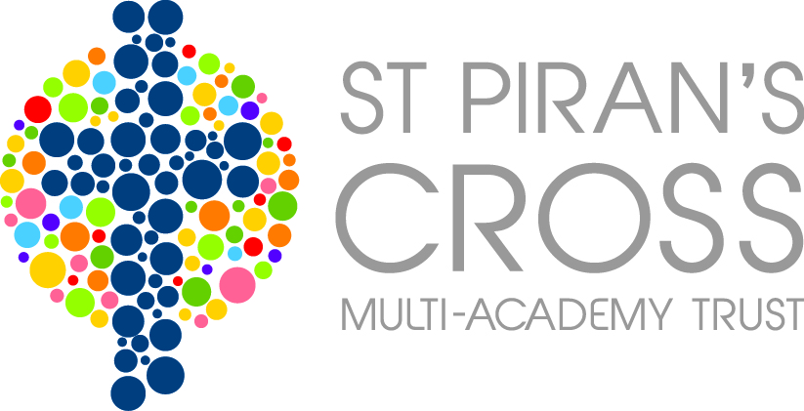

Data Protection Policy

The Data Protection Act 1998 is the law that protects personal privacy and upholds individual’s rights. It applies to anyone who handles or has access to people’s personal data.

This policy is intended to ensure that personal information is dealt with properly and securely and in accordance with the Data Protection Act. It will apply to information regardless of the way it is used, recorded and stored and whether it is held in paper files or electronically.

- Scope of the Policy

Personal information is any information that relates to a living individual who can be identified from the information. This includes any expression of opinion about an individual and intentions towards an individual. It also applies to personal data held visually in photographs or video clips (including CCTV) or as sound recordings.

The trust collects a large amount of personal data every year including: pupil and staff information, contact details, assessment outcomes, recruitment references and financial transactions. In addition, it may be required by law to collect and use certain types of information to comply with statutory obligations of Local Authorities (LAs), government agencies and other bodies.

2. The Eight Principles

The Act is based on eight data protection principles, or rules for ‘good information handling’.

1. Data must be processed fairly and lawfully.

2. Personal data shall be obtained only for one or more specific and lawful purposes.

3. Personal data shall be adequate, relevant and not excessive in relation to the purpose(s) for which they are processed.

4. Personal data shall be accurate and where necessary kept up to date.

5. Personal data processed for any purpose(s) shall not be kept for longer than is necessary for that purpose.

6. Personal data shall be processed in accordance with the rights of data subjects under the 1998 Data Protection Act.

7. Appropriate technical and organisational measures shall be taken against unauthorised or unlawful processing of personal data and against accidental loss or destruction of, or damage to, personal data.

8. Personal data shall not be transferred to a country outside the EEA, unless that country or territory ensures an adequate level of protection for the rights and freedoms of data subjects in relation to the processing of personal data.

3. Responsibilities

3.1 The trust must:

- Manage and process personal data properly
- Protect the individual’s right to privacy
- Provide an individual with access to all personal data held on them

3.2 The trust has a legal responsibility to comply with the Act. The trust, as a corporate body, is named as the Data Controller under the Act.

Data Controllers are people or organisations who hold and use personal information. They decide how and why the information is used and have a responsibility to establish workplace practices and policies that are in line with the Act.

3.3 The trust is required to ‘notify’ the Information Commissioner of the processing of personal data. This information will be included in a public register which is available on the Information Commissioner’s website at the following link:

https://ico.org.uk/about-the-ico/what-we-do/register-of-data-controllers/

3.4 Every member of staff that holds personal information has to comply with the Act when managing that information.

3.5 The trust is committed to maintaining the eight principles at all times. This means that the trust will:

- inform Data Subjects why they need their personal information, how they will use it and with whom it may be shared. This is known as a Privacy Notice.

- check the quality and accuracy of the information held

- apply the records management policies and procedures to ensure that information is not held longer than is necessary

- ensure that when information is authorised for disposal it is done appropriately

- ensure appropriate security measures are in place to safeguard personal information whether that is held in paper files or on a computer system

- only share personal information with others when it is necessary and legally appropriate to do so

- set out clear procedures for responding to requests for access to personal information known as subject access in the Data Protection Act

- train all staff so that they are aware of their responsibilities and of the trust’s relevant policies and procedures

This policy will be updated as necessary to reflect best practice or amendments made to the Data Protection Act 1998.

Please follow this link to the ICO’s website (www.ico.org.uk) which provides further detailed guidance on a range of topics including individuals’ rights, exemptions from the Act, dealing with subject access requests, how to handle requests from third parties for personal data to be disclosed etc. In particular, you may find it helpful to read the Guide to Data Protection which is available from the website.

For help or advice on any data protection or freedom of information issues, please contact the central office.

November 2016

