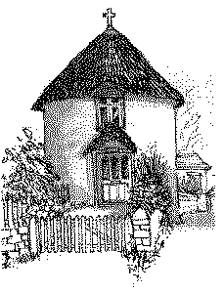
Veryan C of E Primary School – Traffic Light Behaviour System 2017
At Veryan School, we believe praising and recognising positive behaviour is key to ensuring standards of pupil behaviour across the school remain high. There will be times when pupils do not demonstrate behaviour which supports the learning and enjoyment of themselves and others. It is important that all staff across the school are consistent in their approach towards behaviour management and that expectations remain clear across the school.

Step 1:
If a pupil is demonstrating behaviour which does not meet the expected standards, a warning must be given. This warning must also include a reason – for example a child who you have already asked to stop taking to their friends; “Please stop talking on the carpet, this is your warning. If you continue your name will be moved down to yellow”. It is inconsistent if children are moved to yellow without being given a warning and a valid reason.

Step 2:
If the pupil in question continues to display the behaviour for which they have been given a warning for, then move their name down to yellow but you must explain why. The pupil has made the decision to move down by continuing to behave in an inappropriate way. If a pupil has been put on yellow, they will remain on this colour for the remainder of the day.

Step 3:
If the pupil in question continues to display the behaviour for which they have been moved down for, then a further warning must be issued. The Class Teacher will then decide if a child’s name should be moved down to red. If a child is moved to red they will miss part of their playtime (the amount of time will be decided by the Class Teacher).

There are some instances in which it may be necessary for a child to be moved straight from green to red – the decision to move a child from green to red must be made by a Teacher.

Below is a breakdown of the types of behaviours which may warrant being moved down to yellow (by a member of staff) or red (by a Teacher).

Examples of ‘yellow’ behaviour:
- Shouting out in the classroom.
- Talking on the carpet.
- Pushing, shoving and talking when lining up.
- Lack of effort during tasks.
- Poor behaviour in the playground.
A clear warning MUST be given.
Examples of ‘red’ behaviour – sanctioned by a Teacher.
- Continuing to display yellow behaviour after a final warning/
- Aggressive behaviour towards a child or adult.
- Use of inappropriate language.
All children begin the day on green – the aim is for all children to remain on green for the whole day. If children are demonstrating behaviours listed in the ‘yellow’ section – a clear warning & reason must be given.

