Veryan Primary
School News

Friday 3rd February 2017

Carne Class – Pizza Express trip
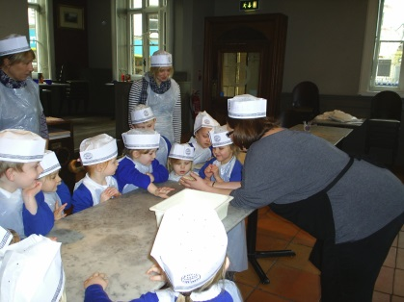

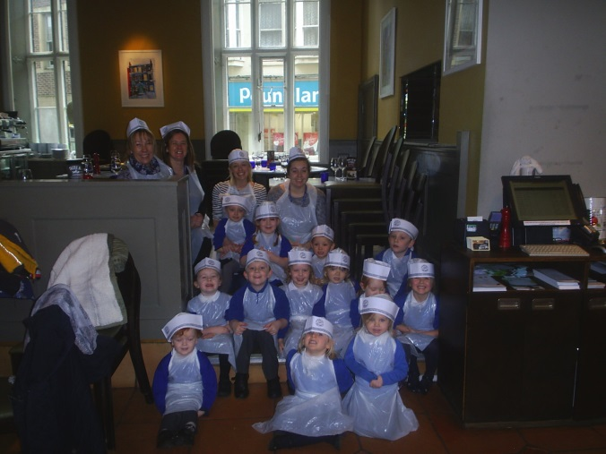

Our Carne Class children had a wonderful morning at Pizza Express, Truro on Thursday. They all made their very own pizzas and explored the tastes and textures whilst thinking about the role of the chef and cooks as part of the children’s immersive curriculum.
We need your help! On Monday your child brought home an envelope containing information about Exemplar Education resources. We would be incredibly grateful if you could return the reply slip regardless of whether you do or do not want to find out more.
If we can get enough slips returned (even if no more information is required) we receive some excellent FREE resources for school.
Many thanks for your support.

Bug Busting Day
Thank you to all the children (and their parents) who took part in our bug busting day with whacky hair styles! It was great fun seeing all the creative and crazy styles on Tuesday and hopefully it served as a good reminder to check your child’s hair for headlice on Tuesday evening? Each family should have brought a free comb home from school – if you didn’t receive one or need a spare, please help yourself to one from the basket in the foyer.

Attendance
The expected average percentage attendance for a child is 96%.
Last week the attendance level of each class was:
- Carne Class –93.8%
- Pendower Class –97.3%
- Kiberick Class –96.7%
Congratulations Pendower class you are this week’s…

Our focus this week has been on ‘Literacy’

Our student of the week for:
Kiberick class – Ben Taylor
Pendower class – Freddie Watson
Carne class – William Kendall

Our Achiever Awards this week go to:

Kiberick class – Alfie Bristow &Talan Spears
Pendower class – Caleb Kendle & William Wilson
Carne class – Isaac White-Tiller & Lottie Beetham

Our lunchtime award goes to: Evie Lobb for lovely dinner time manners and Dom Leach for helping to keep the dinner time queue calm and quiet for Mrs Allan answering the phone!

Residential Meeting

There will be two parent briefing meetings to explain the Year 5 London trip itinerary and distribute the parent booklets. Parents and carers are welcome to attend whichever briefing session is most convenient.

7th March – 4pm Grampound Road School
8th March – 3.30pm Bishop Bronsecombe

If you are unable to attend these meetings your parent booklets will be sent home with your child.

Carne class
If you have any small pipes/tubes milk crates etc that could be used for our outdoor water play area in Carne these would be gratefully received.

Mrs Greenaway would also love to have your old kitchen roll tubes and any pieces of fabric for creative play and imaginative play.
Finally – if anyone has any waterproof containers/salt boxes that items could be kept and stored outside we would love to give them a home!

Thank you in advance.

Library We are very lucky to have Mrs Sparks volunteering to come into school every Wednesday to work with some of our year 6 children to organise the library and keep it in order. It has never looked so good! Mrs Sparks will now be taking a group of children at a time to the library each Wednesday morning so that they can choose a library book to bring home alongside their reading book. Mrs Sparks is hoping to give every child this opportunity each Wednesday.
Children are likely to choose a book that is of interest to them rather than necessarily a book at the correct level for them to read themselves. If this is the case, we would be very grateful if you can find some time to read the book with your child.
Please try to remind your children to bring their library book back to school on a Wednesday if they would like to change their book.
Many thanks to Mrs Sparks for her help with this.
Hearing from families…
...special educational needs Jane Black is the senior member of staff at Cornwall Council for education and Julie le Masurier is the lead person for special educational needs. They both welcome opportunities to hear from families about how aspects of special educational needs are working, or not, for families in Cornwall. They are committed to working with families and young people to improve the life chances of individuals. You may have already been involved in sharing your story and your views for example in recent surveys, or at events like the Aiming Higher Conference. If you would like to speak with Jane and Julie informally face to face and can drop in to any of the sessions below they would be pleased to see you.
This is a new way for families and Council staff to share information about special educational needs. There are no set ideas about this way of meeting but after the sessions have taken place we’ll let you know what happened.
If you would like to attend please book your place by emailing Lianne Symons, PA to Jane Black on lsymons@cornwall.gov.uk
10 February 2017
9:30 – 11:30 - Room 1, Chy Trevail, Beacon Technology Park, Bodmin, Cornwall, PL31 2FR
22 February 2017
1:00 – 3:00 - Fire Service Headquarters Meeting Room, Service HQ, Tolvaddon, Camborne, TR14 0EQ
16 March 2017
12:30 – 2:30 - Alverne Room, St Johns Hall, Penzance, TR18 2QR

Headway
As you know next Friday (10th February) we will be holding a non-uniform day in aid of ‘Headway’ the brain injury charity. We have already received the collection box and it can be found in the school reception area for any donations you wish to make to this worthwhile cause.
Spring term dates dates for your diary…

3rd February – MAT School Council conference – The immersive curriculum, sharing our learning.
10th February – Non-uniform day in aid of ‘Headway’
13th-17th February – Half term
21st February – Carne trip to Tesco (see letters sent home)
2nd March – World Book Day – Dress as your favourite book character!
7th March – St Piran’s Day pasty lunch menu
7th March – Yr5 London residential briefing meeting. Grampound Road School 4.00pm
8th March - Yr5 London residential briefing meeting (rptd)
Bishop Bronsecombe 3.30pm
9th March – Pendower trip to Tesco (see letters sent home)
16th March – Carne class trip to Truro Fire Station.
(letters sent home with more details closer to the time)
23rd March – Open Afternoon – the immersive curriculum
29th – 31st March – Year 5 Residential to London
31st March – Last day of term
25th April – MAT HfC Project 7pm
9th May – Whole class Tempest photography photos
27th June - Year 6 transition day to The Roseland followed by parents’ evening at The Roseland at 6.30pm

Electronic Newsletter
If you would like our weekly newsletter emailed to you, we would love to send it to you!

Please email your request to
vrsecretary@stpiranscross.co.uk

THE ROSELAND MULTI ACADEMY TRUST - Vacancy
JOB DESCRIPTION
Job title: Parent Support Adviser
(Fixed term until 31.8.2017)

Hours: 8 – 10 hrs per week term time

Grade: F1 – F6:

Responsible to: Leadership Team

Direct Supervisory Responsibility for: None

Indirect Supervisory Responsibility for: None

Purpose of the post:
* To work in partnership with parents/carers to improve children’s lives, by involving parents in identifying appropriate support for the child and family.
* To identify the most effective ways of delivering early intervention and preventative support to parents/carers and students from within schools.
* To work in partnership with schools and other agencies to inform thinking and delivery around Parent Support. Parents/Carers are taken to include all those who provide significant care for children in a home or family context, including biological parents, step-parents, foster parents, adoptive parents, grandparents or other relatives.

(If you are interested in this post or would like more information please ask Mrs Allan in the office.)

