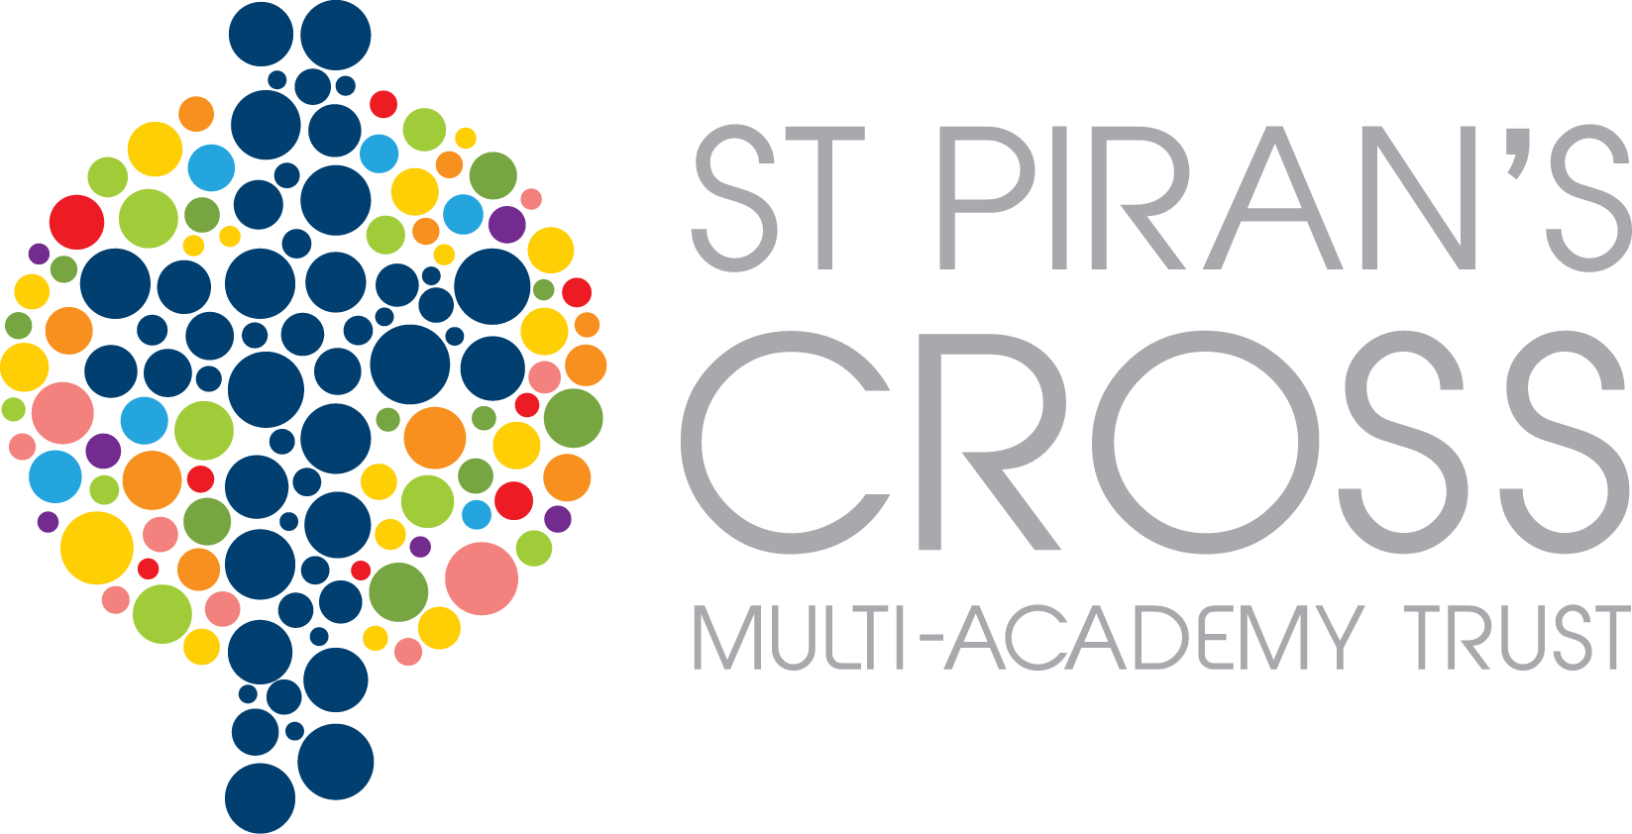

Veryan C of e School



SCHOOL SELF-EVALUATION 2017

Thank you very much for taking the time to complete the self evaluation questionnaire a few weeks ago. We had 19 returned which is a great proportion for a small school. Below are the results and comments. There were many positive comments for which we are very grateful and feel very proud. We are also pleased to receive the constructive criticisms as this gives us something to work on.

Mrs Michell

 |  | Agree | Disagree | Don’t know
1 | My child is happy at this school. | 100% | 0% | 0%
2 | My child makes good progress at this school. | 95% | 5% | 0%
3 | My child is well looked after at this school. | 100% | 0% | 0%
4 | My child is taught well at this school. | 100% | 0% | 0%
5 | My child receives appropriate homework for their age. | 95% | 5% | 0%
6 | The school makes sure that its pupils are well behaved. | 95% | 5% | 0%
7 | The school deals effectively with bullying. | 42% | 0% | 58%
8 | The school is well led and managed. | 90% | 5% | 5%
9 | The school responds well to any concerns I raise. | 89% | 5% | 5%
10 | I receive valuable information from the school about my child’s progress. | 84% | 5% | 11%
11 | I am happy to recommend my school to other parents and carers. | 100% | 0% | 23%
12 | St Piran’s Cross CE MAT supports and challenges my school appropriately. | 42% | 2% | 58%
13 | St Piran’s Cross CE MAT extends the opportunities offered to our children by my school. | 58% | 0% | 42%
14 | The MAT is well led and managed. | 53% | 5% | 42%
15 | I am happy to recommend St Piran’s Cross CE MAT to other parents and carers. | 74% | 5% | 21%

General comments about the school

*Very happy with all aspects of school life. A very warm and welcoming environment. Thank you!

*I think a piece of homework from each of the core subjects would be more challenging for children in Key Stage 2, rather than one easy piece of maths homework plus a topic based piece from the menu sent home. More frequent and challenging homework in the core subjects would better prepare them for secondary school. Also, it would be much better to have separate hand in and hand out days so that homework was always marked.

*Most parent forums, PFA meetings etc are scheduled during working hours, so feel a total disconnection between anything discussed during these and working parents. Feel that the weekly award system should be year based rather than class based.

*I cannot praise Veryan School enough. I’m proud to tell people my children go to our school. The staff are amazing. They are professional, kind, caring, approachable and friendly. Both my children are very happy at school, they feel safe and happy. Good job everyone!

*I think Veryan School is a very caring school and all the teachers and support staff do an excellent job of looking after my children. My children are very happy at school and I feel they are being taught well and always encouraged to do more if they can.

*An idea of school daily structure would be handy. It took me 6 months to find out about a reading lotto and a further 3 months to hear about tuck (although I’m still unsure as to what this is). I hear there’s a new focus on mindfulness – this could do with being explained fully to parents.

*Homework –if set should be marked. Too often the homework is completed but not given any feedback – doesn’t engender enthusiasm from child or parent.

*My child is very happy at Veryan and it continues to be a nurturing environment despite the turbulent times over the past couple of years. Mrs Michell has been a valuable head and has steered the school in a positive direction. I am concerned that the mass change of staff in September will prove tricky for some pupils and parents and will not necessarily reflect positively in the wider Roseland community for our school. I welcome the new Head who I hope will create a dynamic and secure future for our school. I feel Veryan needs to be promoted in order to attract more pupils, especially from the wider Roseland community.

*I am greatly impressed with the immersive curriculum and school trips offered at school. My son has loved the topics and thoroughly enjoyed the style of teaching. I can’t praise the Pendower teacher enough who has understood our son’s learning needs including the rest of the class and we are really sad that they are leaving. Excellent communication of day to day information.

*My daughter has had a fulfilling time in nursery and through school trips, interesting and interactive topics, she is now ready to begin school. Currently there is excellent nursery provision which we hope can continue in order to encourage new families near and far into the school. My daughter has thrived on learning from the other children, there is a lovely warm and nurturing environment and she is very settled.

*Looking forward to meeting the new Headmistress. Would love more information about child’s progress in education and also socially how they’re getting on day to day.

*Myself and my husband are very happy with the progress our son is making. His confidence has grown amazingly and his excitement and enthusiasm to come to school gives us both great pride in how well he and the school are working.

General comments about St Piran’s Cross CE MAT.

*It has been a big change to have the MAT involved with Veryan School. I feel as time has gone on, things have settled down. It will be interesting to see how this next academic year develops….

*Although it is evident that the MAT creates opportunities and links to other school organisations, I am yet to be convinced that Veryan really benefits from being part of it. The decision by the MAT to change all teaching staff, along with the class structure form September has made me question whether I want to keep my children at the school if similar things are to happen each academic year. At present, I do not feel confident in the long term future of the school under the umbrella of the MAT. I hope I will be proven wrong!

*I think many feel there was limited consultation from the MAT regarding the great many changes we are experiencing and that these changes will not necessarily be for the better.

*I hope we continue to receive communication form the MAT in place of Mr Lees.

*Brilliant!

Message from Mr Lees
The set up costs for the merged MAT are coming from funds given to the Saint’s Way from the DfE and not our current budgets.
All decisions made by the MAT Board place each and every child at the heart of these and make the best use of the funds we have available each year.
Thank you for the other constructive comments about our trust that we will take forward.

