**Veryan Primary School News**



Friday 18th March 2016



**Talk Topic –**

***Christian Values Challenge***

**Draw some of the symbols of Easter and write down what they mean.**

**SPRING TERM 2016 DATES**

**Dates for diaries:**

17th March – Centenary Shield Match

18th March – SAT paper orders (see overleaf)

21st March - **Whole school photograph**

21st March – Annual Reports sent to parents

21st March Roseland TAG Rugby Festival

24th March – Last day of the spring term

11th April - New term begins

Our **Student of the Week** for Creativity



Carne class is: Teddy Stephens



Pendower class is: Phoebe Emmett

Kiberick class is: Sonny White

Our **Achievers of the Week** are:

Carne class: William Etches & Ellie Lobb

Pendower class: Kayleigh Vincent & Evie Hepworth

Kiberick class: Katie Wright & Issy Wheeler

Well done to you all for your hard work!

**After School Clubs**

All after school clubs will finish this week ending 18th March. Look out for information about your club choices and days in the new term!

**...More Proud moments from Veryan...**

**Cornwall Music Festival**

Congratulations to Pendower and Kiberick children who attended the Cornwall Music Festival at Truro Methodist Church on Monday.

Your behaviour was exemplary and you gave brilliant performances.

The children achieved a Merit grade and were given some excellent hints and tips for future performances and all had a super experience. Well done!

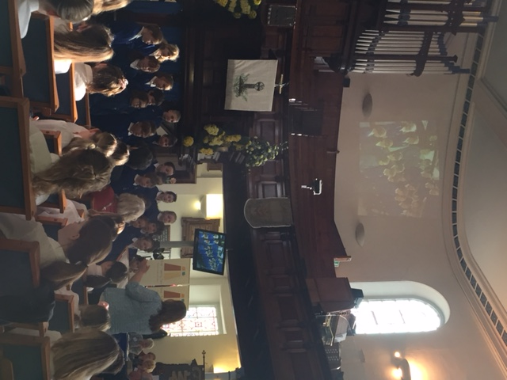

**Girls Football Match at Tregony**

Some of our girls joined Tregony school in a friendly football match on Tuesday afternoon. They all demonstrated excellent sporting behaviour and Issy displayed some fantastic goal keeping skills! A 0-0 score but what a match!

**Easter Church Service**

We are holding a special Easter Service on Thursday 24th March at Veryan Church. In addition to our usual service and celebrations the choir will be performing the songs they sang at the Cornwall Music Festival.

Everyone would be very welcome to attend.

**Attendance**

The expected average percentage attendance for a child is 95%.

Last week the attendance level of each class was:

* Carne Class – 96.7%
* Pendower Class – 93.6%
* Kiberick Class – 95.3%

**Parent texting service.**

Teachers2parents text service update: Some parents/carers requested that school texts were sent to more than one mobile number. This should be up and running very soon.

Please can we remind everyone to ensure that phone numbers and emergency contact details are kept up to date with the school office. Many thanks.

**Parent Forum** Thank you to the parents who attended our Parent Forum with Mr Lees and I on Wednesdayevening. This is a chance for parents to bring their ideas and concerns to discuss with the leadership of the school and our Trust. We had a wide ranging and worthwhile discussion, below is a summary of these:

**1. Positive feedback about our work** A parent wanted to say how pleased she was with the work the children were doing, the kindness of the staff, how welcome she felt in the school and the positive way in which school dealt with parents and children.

**2.Communication** Parents were pleased with the use of the text service to update them on school events and any changes to the planned programme. Parents would be grateful if more than one mobile number could be included and Mr Philips said he would look into this.

**3. Website** The school website is rather old fashioned. The Trust are currently in discussion to make this more up to date and relevant for parents. More on this during the summer term 2016.

**4. Classes and teachers** A parent asked if teachers ever moved between schools in the MAT. Mr Lees confirmed that this was possible and the teachers at Veryan gained from being part of a larger team with all the experience and expertise this offered.

A discussion followed about budgets and class options for September 2016. Mr Lees said that the schools budget had only just arrived and the trust was currently looking at how to organise the school in September. The school roll like most of the Roseland schools is falling and so is the budget. Parents will be informed of the planned proposals in the first part of the summer term and no later than just before the May half term.

**5. Veryan’s League table position** Concern was expressed at the drop in Veryan’s league table position last summer. Mr Lees confirmed that the school and trust were disappointed with this and had been working hard since September to introduce the new national curriculum and the raised expectations. The cohort tested last summer was small and some children arrived at the school much later which affected the overall results. Results in the EYFS, year 1 and 2 were better than the national average in 2015.

**6. The New SATs in 2016** A parent asked about the new national tests for 2016 which appear to be considerably harder than in previous years. The school agreed that they are! A briefing meeting is planned for Year 2 and 6 parents early next term to explain the new tests and what the school is doing to prepare the children for these and how our parents might help their children to be ready to achieve their best.

**Parking** Please could we ask parents/carers to ensure they park considerately and do not block entrance or access areas around the neighbouring houses/lanes. We know at the beginning and end of school it is difficult to find a parking space and appreciate you working with us within our local community.

**Weekly food orders** Please note that on Thursday 24th March there will be a special Easter menu from Chartwells. Children can choose from:

Fish fillet & chips

Or

Cheese and Onion pasty & chips

The salad bar will be available as normal and the children can select their own dessert on the day.

Please order/amend your choices at the office as soon as possible.

We will be having an exciting new menu from Chartwells after the Easter break, so a new order sheet will be sent home. Again, this can be completed with your child and kept at school on a 3 weekly cycle, or if you prefer to choose on a weekly basis, please remember to complete and hand in your choices at the school office/post box by Monday morning.

If you haven’t already handed in your advance food orders please can we remind you to return your weekly order slip with Thursday’s special choice marked. (**Week 2. 21st March)** on **Monday morning**.

**Year 6 SAT’s Exam papers -**

**Deadline reminder!**

Thank you to those parents/carers who have already responded to the offer letter sent out for the Ninja Exam practice SAT papers. The deadline for ordering the papers is **Friday 18th March.** We hope to be able to place the order and receive the papers for distribution before the Easter break.



Easter Egg Hunt

Easter Monday

Veryan sports and social club

11am.  £2 to hunt

Refreshments and Teddybear Tombola

Any good quality teddy bears and soft toys needed for the teddy bear tombola. Please give to Olivia Lobb



Messy Church is popping up again in the Easter holidays on:

Thursday, 31st March 12-1.30pm.

Craft and lunch on offer.

Come and go as you like.

Jill Edwards. *Priest in Charge. 01872 580117*

**VERYAN MARKET**First Saturday of every month  
10.30 - 12.30  
VERYAN PARISH HALL  
Home Baking,Local Meat & Veg,  
Preserves,Plants,Handicrafts & more  
Meet up with friends and enjoy coffee & homemade cakes  
We would love to see you there!

**Easter Egg Hunt**



**At**



Good Friday 10.30am-3.00pm

£3.00 per child

**Easter Craft Workshops**

will be running throughout the day at

£5-£12.50 per project.

Refreshments available

Please ring 01872 501502 to book your place and for more information.



.

.