 | Medium Term Plan
 | Spring Term 2 | Carne Class | Mrs Coley
Spoken Language  Reading  Word Reading  Comprehension  Writing  Phonics and Spelling  Punctuation  Vocabulary  Sentence and Text  Handwriting and Presentation  Literacy  Writing simple words, simple sentences  using adjectives, commas and consistent punctuation  Jack and the beanstalk story – storytelling into writing  Character descriptions  News report  Role Play Area  Home corner  Plant Centre/Flower shop  Composition  Story  Information  Poetry  Science  Working Scientifically - Planning  Working Scientifically - Recording  Evidence  Working Scientifically - Conclusions  Plants  Animals, including Humans  Life Processes  All Living Things  Habitats  Everyday Materials  Changing Materials  Light and Sound  Electricity  Forces & Magnets  Mathematics  Problem Solving  Geography/History  Local area/village  Local visit to Lost Gardens of Heligan  Communicating  Reasoning  Number and Place Value  Mental Maths  Operations - Addition  Operations - Subtraction  Operations - Multiplication  Operations - Division  Written and Calculator Methods (KS2)  Written Methods - Addition  Science  How do plants grow? What do they need?  What are wild flowers?  What’s the name of that plant?  What are the different parts of a plant called?  Written Methods - Subtraction  Written Methods - Multiplication  Written Methods - Division  Fractions and Decimals (KS1)  Fractions, Decimals, percentages (KS2)  Algebra (KS2)  Ratio and Proportion (KS2)  Geometry - 2D Shapes  Geometry - 3D Shapes  Position and Direction - ICT (KS1)  Position and Movement (KS2)  Measures - Length  Measures - Mass  Measures - Capacity & Volume  Measures - Time  Statistics - Processing and representing data  Statistics - Interpreting data  Physical Education  Monday/Tuesday morning with Mr Jarvis - Multiskills | Writing Genre  Story Poetry Non-chronological Instructions  Newspaper reports Letters Play scripts Recount  Persuasive Explanation Biography Autobiography  Maths Focus  Problem-Solving Use & Application  Number & Place Value Mental Maths Algebra Geometry  Number Operations Statistics Ratio & Proportion Measures  Written Methods Fractions, Decimals & Percentages Position & Direction  How magic were Jack’s beans?  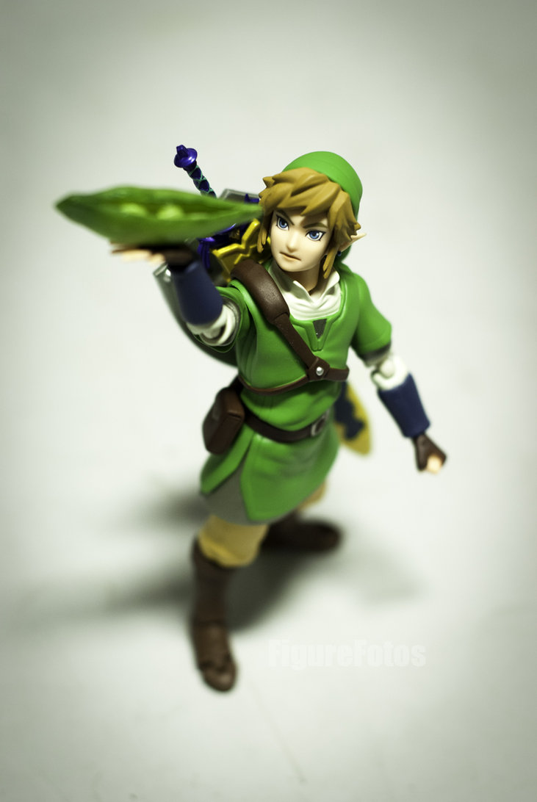  Computing  Word processing  Mouse control  Researching information  Opportunities for Outdoor Education  Exploring the school grounds/park and comparing with our story settings.  Map drawing.  SMSC  British Easter customs  Royal Family |  |  | Computing  Finding Things Out  Making Things Happen  Programming  Sharing & Reviewing  Investigating and Exploring  Art & Design  Drawing  Painting  3D Modelling  Printing  Numeracy  Focus for Spring Term 2  Telling the time  Dates/days/months  Number bonds within 20/50  Multiplying by 2 and 10  Capacity  Weight  Mental maths strategies & activities.  Using & Applying / Outdoor Maths.  Textiles  Design & Technology  Design  Make  Evaluate  Axles, Pulleys and Gears  Electrical and Mechanical  Components  Food Technology  Mechanisms  Structures  Textiles  Geography  Geographical Enquiry  Geographical Skills  & Fieldwork  Location & Place Knowledge  Human and Physical  Religious Education –  Why do Christians celebrate Easter?  Sustainability  History  Finding Out About  the Past (Enquiry)  Finding Out About  the Past (Chronology)  Historical Events  Lifestyles of People in the Past  Significant Historical People  Religious Education  Learning about Religion  Learning from Religion  Modern Foreign Languages  Listening and Responding  Speaking  Writing  Physical Education  Art / DT  Paper flowers  Garden collage  Gymnastics  Dance  Games  Swimming  Music  Nursery rhymes  Magical music sounds

