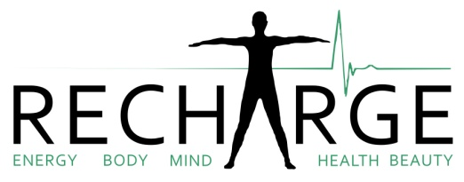

Dear Teachers and Parents,
As more of us become aware of “mindfulness” and the benefits we can gain from this simple practise, it makes enormous sense to begin at an early age.
There have been many reported benefits in children who have to sit tests; perhaps you have seen this in the media? They are reporting to feel less anxious, more calm and happy and parents and teachers have been commenting too on individual progress of children partaking in yoga classes.
For example, better sleep, and more chatty and confident in the classroom leading to achievement stars.
Sophie has been running yoga classes in St Mawes since last November and on the Roseland since 2013. She has taught fitness and dance to children and in November began to teach yoga to children too.
She has recently taken a further educational course through YogaBeez “Children and Mindfulness Teacher Training” and would love to extend these teachings to your child!
Your child will be inspired to feel empowered, engaged, entertained, exercised and educated through a number of inter-curricular techniques. They will be exploring geography, maths and anatomy but through fun, play, movement, yoga poses, sensorial education, breath awareness, mindfulness and relaxation.
After the summer half term there are 7 weeks of Children’s yoga and mindfulness classes from Wednesday 7th June to Wednesday 19th July 2017.
Sophie comes especially to St Mawes to empower your children through yoga with the wonderful side effect of increased strength and flexibility and compassionate beings! It is an amazing opportunity here to plant the seed early on for a stronger basis and understanding through to teen and adult life.
Special offer- 7 classes for 6 weeks. £30
Or pay as you go is possible at £5/ class

The children and classroom will benefit most with regular weekly attendance. So it is warmly encouraged to commit to the full 7 weeks as much as possible.
Full class schedule:
Wednesdays in term time Millenium Rooms- St Mawes
Please bring a mat if possible, blanket, bottle of water and wear comfortable stretchable clothes.

4.30pm- 5.15pm Childrens yoga- age 4 to 9 years
5.30pm- 6.45pm Adults Vinyasa Flow
7.00pm- 8.00pm Hatha Yoga and relaxation

sophiemydlarz@hotmail.com
07553 980723
Recharge Therapy (Facebook)
Please make contact with Sophie directly to express interest for an idea of numbers by telephone or email. Many thanks.

