Schools covered by Kathy:
Grampound Road
Ladock
Roseland Academy

Schools covered by Lyn:
Gerrans
Grampound with Creed
Gorran
Probus
St. Mawes
Tregony
Veryan
Roseland Academy

Wherever you live on
The Roseland, Parent Support
Advisers can offer free and
confidential support.

Kathy Marris

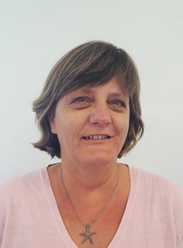

07854494027
Kmarris@theroseland.co.uk

Lyn Bell

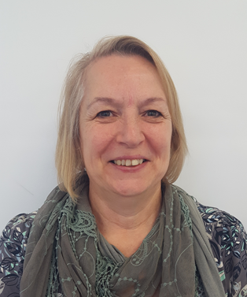
07929365227
lbell@theroseland.co.uk

tmorse@theroseland.co.uk

Parent Support
Adviser

Parenting is not an easy job, and at times things can get tough.
Parent Support Advisers are here to help provide a seamless link between home and school that promotes a positive attitude towards education.

What do we do:
- Encouraging positive links between parent/carer and School
- Help parent/carer feel confident to engage with their child's learning
Assist and support around transition stages
- To help with issues around attendance
- Signposting to other agencies
- Enabling participation in the Common Assessment Framework (CAF)
- Delivering evidence-based parenting programmes

We do this by:
- Targeted individual pupil support,
- Working to an action plan with a family on identified n eeds
- Parenting groups- various ages and needs
- Meetings can take place within school, at home or in a neutral venue
- Initiate and support families with the CAF process,
- Linking with primary schools to identify, and give additional support to some pupils during the transition process

Our approach:

- Flexible, approachable and creative
- Open and transparent, working with other agencies where appropriate
- Home visits/overcoming rural isolation
- Inclusive of fathers/partners, grandparents and within split families
- One off support for parents/carers after cases have closed
- Completely free!
- Absolutely confidential, within safeguarding procedures

