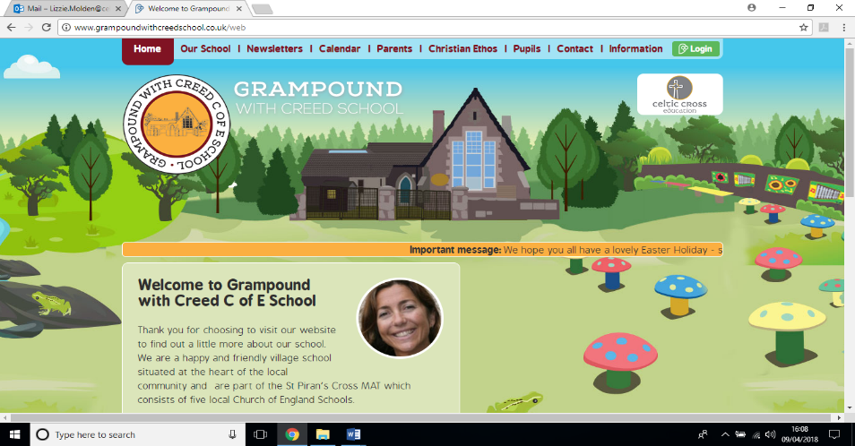

**Ancient Egypt**

**Pendower Class**

**Essential Knowledge / Skills**

By the end of this unit the children will know…

* When are we talking about when we say the Ancient Egyptian Civilisation?
* Where were the Ancient Egyptians?
* What was life like in Ancient Egypt?
* What happened to the Ancient Egyptians?
* What kind of world did Jesus want?
* How can animals be classified?

**Links to Christian values – compassion, perseverance, wisdom**

Compassion

Investigating how changes to the environment can impact the lives of animals and what we can do to challenge negative impacts that we have on the environment.

Asking the question What kind of world did Jesus want? And thinking about ways that we can act to encourage this.

Perseverance

We will be continuing our work from last term where the children became really excited by growth mind set and ways that we can deal with potential frustration when things are tricky. This will remain a focus.

Wisdom

Interpreting information from the bible and how it tells Christian’s about the kind of world Jesus wanted.

**SMSC / British values links**

**British values**

Democracy – Fairness in decision making about things that occur within the class.

Mutual Respect – Focussing on the way that we speak to other people and working together to celebrate each other’s achievements.

Individual Liberty – Having the right to make our own choices in our learning, we will be able to follow our own interests within the topic and carry out research.

**SMSC**

Spiritual and moral – We will be thinking about and taking action on the things that we can do to make the world more like Jesus would have wanted.

Social – We will build up an Ancient Egypt art exhibition as a class, being mindful of including everyone and working as a team.

**Veryan School Topic Plan** 

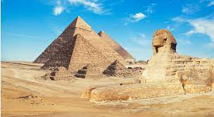



**Computing**

This term we will be focussing on using the internet effectively to find information about Ancient Egypt. This will include using search engines efficiently and storing websites under favourites.

In addition, we will use the information that we gather, to create powerpoints. This will involve the children finding out how to present information in powerpoint, change the layout of slides, insert transitions and inserting images.

**RE Week - What kind of world did Jesus want?**

* Children will know that:
* Christians believe Jesus challenges everyone about how to live — he sets the example for loving God and your neighbour, putting others first.
* Jesus shows love and forgiveness to unlikely people.
* Christians try to be like Jesus — they want to know him better
* and better.
* Christians try to put his teaching and example into practice in lots of ways, from church worship to social justice.

**Art & Design / Design Technology**

* Throughout the course of this term, we will be making Egyptian artefacts to build up a class exhibit, using a variety of methods and materials.
* We will be transforming ourselves into pharaohs, by making pharaoh portraits.
* We will be mummifying fruit and creating Canopic jars in which to do this.

**Maths - White Rose Coverage**

* Fractions (Year 2, 3 and 4)
* Measurement – Time (Year 2)
* Money (Year 4)
* Geometry – position and direction (Year 2)

**Science Week – Animals, living things and habitats**

* We will be learning about teeth, skeletons and muscles.
* We will be finding out about ways that animals can be classified and use classification keys to help group, identify and name different types of animal.
* We will be investigating how changes in environment can impact on the habitats of animals and potentially pose a danger to living things.
* Construct and interpret food chains, identifying predators, prey and producers.

**PE**

* Dance
* Rugby
* Multi Skills

**Writing**

* Writing will mostly be based around the book The Time Travelling Cat and the Egyptian Goddess. We will:
* Write character and setting descriptions related to the book
* Write diary entries about the day the cat came alive.
* Write non-chronological reports about Egyptians.
* Write time travel stories.
* We will be revising the spelling, punctuation and grammar taught within each year group.

**Reading / Key Texts**

* **The Time Travelling Cat and the Egyptian Goddess**
* **Max and the Millions - Guided Reading**
* **Non-fiction texts related to Ancient Egypt**

**Music**

We will be using the online tool Charanga to get to know a piece of music and begin developing improvisation skills to that music, as well as using tuned and untuned instruments.

**Foundation Subjects**

**History / Geography**

* We will be finding out who the Ancient Egyptians were, where they came from, what their lifestyle was and how the Nile impacted on the way that they lived their lives.
* We will also be learning about what is left of the Ancient Egyptians and how that has allowed us to find out more about them.

**Non topic based**

**Ancient Egypt – Theme Content**

**Core Subjects**

**Applied Maths**

* During our wild tribe sessions, we will be combining Maths we have learnt over the whole of the year to complete outdoor, real life challenges.



**Ancient Egypt – National Curriculum & Skills progression**

**Core Subjects**

**Foundation Subjects**

**Writing**

* Writes sentences that are sequenced to form a short narrative (real or fictional) (Y2)
* Develops positive attitudes towards, and stamina for, writing, by writing for different purposes. (Y2)
* Make simple additions, revisions and proof-reading corrections to their own writing (Y2)
* Discusses writing similar to that which they are planning to write and understands and learns from its structure, vocabulary and grammar. (Y3 + 4)
* Assesses the effectiveness of their own and others' writing and suggests improvements. (3 + 4)

**Reading / Key Texts**

* **The Time Travelling Cat and the Egyptian Goddess**
* **Max and the Millions - Guided Reading**
* **Non-fiction texts related to Ancient Egypt**

**Applied Maths**

* Solves simple problems in a practical context. (y2)
* Solves problems that involve Year 3 and 4 mathematical understanding in a practical context.

**History / Geography**

* Year 2 - Put things in order within the topic. Offers opinions and facts with some reasoning. Answer simple questions relating to the topic.
* Year 3 - Order events over a larger timescale. Distinguishing between fact and opinions and given reasons. Children pose own questions to gain an understanding of the topic.
* Year 4 - Beginning to think about the impact of historical events/people. Understanding the difference between primary and secondary sources. Generate purposeful questions.

**Art and Design / Design and Technology**

* Introduce sculpture materials including clay and tools to create decorations on clay including engravers and embossing tools.
* Combine materials and give reasons for choices.
* Decoration techniques such as embossing, engraving and imprinting.
* Mixing tertiary colours (browns, neutrals, flesh.)
* Use sketches, labelled diagrams and notes to explain their design.
* Explain their ideas, the purpose, choice of materials, any necessary changes and how it will be made.

**RE Week**

* I can identify how religion is expressed in different ways. (2)
* I can make links between beliefs and sources, including religious stories and sacred texts. (3/4)
* I can identify the impact religion has on believers’ lives. (3/4)
* I can describe some forms of religious expression. (3/4)
* I can make links between values and commitments, and my own attitudes and behaviour. (3/4)

**Science Week**

* Identify that humans and some other animals have skeletons and muscles for support, protection and movement

Identify the different types of teeth in humans and their simple functions

* Construct and interpret a variety of food chains, identifying producers, predators and prey
* Recognise that living things can be grouped in a variety of ways
* explore and use classification keys to help group, identify and name a variety of living things in their local and wider environment
* Recognise that environments can change and that this can sometimes pose dangers to living things

**Non Topic Based**

**Computing**

Type a URL to find a website.

Add websites to a favourite list.

Use a search engine to find a range of media e.g. images, text.

Think of search terms to use linked with questions they wish to answer.

Talk about the reliability of information on the internet e.g. the difference between fact and opinion.

Create a slide and choose a style.

Change the layout of a slide.

Insert a picture/text/graph from the internet or personal files.

Decide upon and use effective transmissions.

**Music**

Know the difference between pulse and rhythm.

Internalise the pulse in music.

Start to use musical dimensions vocabulary to describe music–duration, timbre, pitch, dynamics, tempo, texture, structure.

Improvise within a group using more than 2 notes.

**PE**

Perform dance actions with control and co-ordination.

Can choose appropriate movements to communicate mood / feelings / ideas

Link two or more actions in a sequence.

Give praise and suggest next steps to peers

**Maths - White Rose Coverage**

* Fractions (Year 2, 3 and 4)
* Measurement – Time (Year 2)
* Money (Year 4)
* Geometry – position and direction (Year 2)