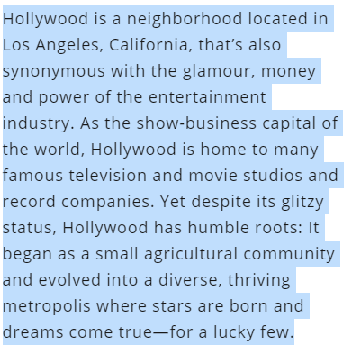

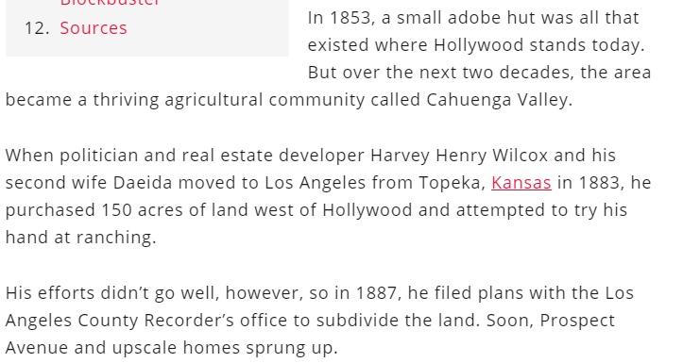

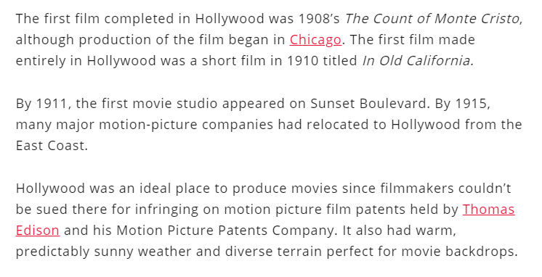

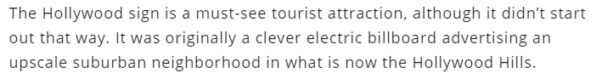
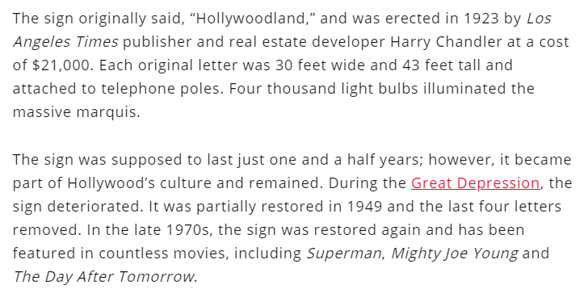

The Golden Age of Hollywood was a period of great growth, experimentation and change in the industry that brought international prestige to Hollywood and its movie stars.
Under the all-controlling studio system of the era, five movie studios known as the “Big Five” dominated: Warner Brothers, RKO, Fox, MGM and Paramount. Smaller studios included Columbia, Universal and United Artists.
The Golden Age of Hollywood began with the silent movie era (though some people say it started at the end of the silent movie age). Dramatic films such as D.W. Griffith’s The Birth of a Nation (1915) and comedies such as The Kid (1921) starring Charlie Chaplin were popular nationwide. Soon, movie stars such as Chaplin, the Marx Brothers and Tallulah Bankhead were adored everywhere.
With the introduction of movies with sound, Hollywood producers churned out Westerns, musicals, romantic dramas, horror films and documentaries. Studio movie stars were even more idolized, and Hollywood increased its reputation as the land of affluence and fame.
During World War I, after President Woodrow Wilson declared war on Germany, the Big Five jumped on the political-propaganda bandwagon.
Often under pressure and guidance from the Wilson administration, they produced educational shorts and reels on war preparedness and military recruitment. They also lent out their wide roster of popular actors to promote America’s war efforts.
By the 1930s, at the height of Hollywood’s Golden Age, the movie industry was one of the largest businesses in the United States. Even in the depths of the Great Depression, movies were a weekly escape for many people who loved trading their struggles for a fictional, often dazzling world, if only for a couple of hours.
Despite the tough economic times, it’s estimated up to 80 million Americans went to the movies each week during the Depression.
Some of the greatest films made in all of Hollywood history were made in the late 1930s, such as Snow White and the Seven Dwarves, Mr. Smith Goes to Washington, Gone with the Wind, Jezebel, A Star Is Born, Citizen Kane, The Wizard of Oz, Stagecoach and Wuthering Heights.

