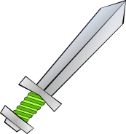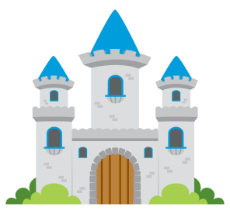 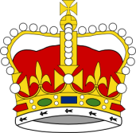

**Science week and incorporate throughout topic with higher order questions and in continuous provision  
Week 1:** To explore and identify a range of materials and state their uses.  
To identify the most appropriate materials for making certain objects – advantages and disadvantages.  
**CP Investigation:** Which material will make the best shield? **CP Investigation:** Which material would make the best waterproof outfit for a knight?  
**CP Investigating forces** – push and pull to move a heavy cannon.

**Music  
Week 1:** To understand a steady beat. **Week 2:** To control a steady beat.  
**Week 3:** To understand rhythm.  
**Week 4:** To combine beat and rhythm.  
**Week 5:** To use beat and rhythm to accompany songs and stories.

**Crowns and Castles.**

Spring 1: 6.1.20

**Phonics:  
Week 1:** ay, ai, ee, igh, ie. **Week 2:** oa, ow, ou, oo, *oo.*  
**Week 3:** oi, oy, or, ir, er.  
**Week 4:** ur, ure, air, ear, a-e.  
**Week 5:** e-e, i-e, o-e, u-e x 2.

**ICT  
Week 1:** To log into an account and interact with a theme.  **Week 2:** To choose a picture and write a caption (Castle Captions).  
**Week 3:** To paint a castle (Paint Project: Castles).  
**Week 4:** To read and respond to a video clip (Knight Diary).  
**Week 5:** To design a national flag (Paint Project: Flag).

**RE- Understanding Christianity   
Week 1:** The Bible as a holy book and identify their favourite book. **Week 2:** Noah and the Ark.  
**Week 3:** Moses and the Red Sea.  
**Week 4:** Jesus and Paul / Saul.  
**Week 5:** Jesus and Peter.  
Within this, cover the concept of the Old and New Testaments and why they are so.

**PSHE and TIS - Getting On, Falling Out  
Week 1:** Being a good friend - what it means and good listening. **Week 2:** Seeing things from another POV.  
**Week 3:** Working together.  
**Week 4:** Managing feelings of anger.  
**Week 5:** Resolving conflicts.

**PE Term 3:1:** Gym - Medieval dances and games.   
Outdoor – bats and balls, footballs (cannonballs).

**Geography/History  
Week 1:** To recognise the current and historical role of kings and queens.  
**Week 2:** To understand what the Magna Carta is and why it was signed.  
**Week 3:** To understand the concept of a knighthood.  
**Week 4:** Castle geographical locations and floor plans – aerial viewpoint perspective.  
**Week 5:** Castle life – banquets, jousting, attack and defence, etc.

**Art and DT  
Weeks 1&2:** To design and create a symmetrical coat of arms.  
**Week 2:** Paul Klee’s ‘Castle and Sun’.  
**Week 3:** Moving Pictures – Jousting Horse.  
**Weeks 4&5:** To plan, design and make, using salt dough, a crown.

**Literacy**

**Weeks 1&2:** Jack and the Beanstalk -

characterisation, settings and innovation.

**Week 3:** Information Texts - Writing a non-fiction book about castles. Labelling castles.

**Weeks 4&5:** Beauty and the Beast - characterisation, settings and innovation.

**Guided Reading:** See phonics   
**Phonics:** RWI streamed groups as assessed  
**Grammar:** Sentence level starters focused on the inclusion of adjectives and connectives.

**Numeracy**  
**Week 21: Number and Place Value** - Find one more / less, 10 more / less than any 2-digit number.  
**Week 22/23: Mental Addition and Subtraction** - One digit add/take one digit, two digit add/take one digit, addition/subtraction number sequences and word based problems. Adding three numbers. Doubles and number bonds.  
**Week 24: Measurements and Statistics** -   
Identifying appropriate instruments and units of measurement, measure weight and capacity using uniform non-standard units, complete tables and block graphs, recording results and information. **Week 25: Fractions and Money -** Odd and even, halving and quartering of shapes, coinage.