Reception Maths activity -Sorting objects in different ways.
A group is a number of objects that are the same in some way. They may be the same colour or the same size, the same animal or from the same family or category. Draw a circle around each group.
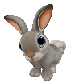
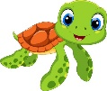
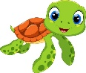

Sometimes we group things that come from the same ‘category’. A category is like a family. One category might be called ‘fruits’ another could be vegetables, another could be vehicles.

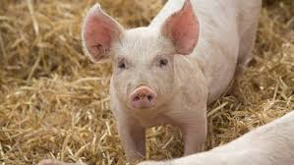
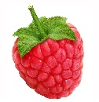
Can you draw around these pictures to make different groups:
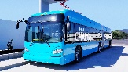
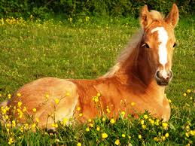
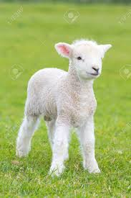
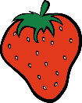
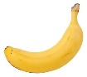
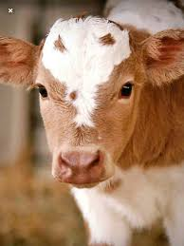
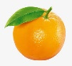

How many different groups did you find? ……………………………………………..
Could you give each group you found a name?

1………………………………………………………………………
2……………………………………………………………………...
3………………………………………………………………………

