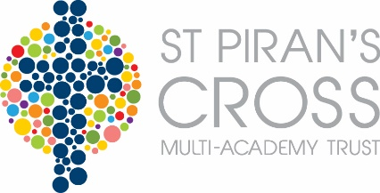
St Piran’s Cross C of E Multi-Academy Trust
Pupil Premium Report – Veryan
Report Period 1st September 2016 - 31st August 2017
This funding was received after conversion to a Multi-Academy Trust during the grant period 2016/2017 and 2017/2018.
PPG provides funding for two policies:
• Raising the attainment of disadvantaged pupils and closing the gap with their peers; and
• Supporting children and young people with parents in the regular armed forces

The period of reporting spans over two different grant allocations. Please see information below.

Pupil Premium Grant (PPG) Received
1st September 2016 - 31st August 2017
Funding carried forward from previous period |  | £0
Total amount of funding received in this period |  | £10,678.33
Total amount of funding received |  | £10,678.33
Nature of Support | Amount | Impact Statement
TAs interventions | £9,228.11 | Groups of children involved in small group interventions and teaching on a daily basis. Progress and attainment measured on school tracking system ‘Incyte’.  As seen on opposite table; nearly all year groups had PP children achieving higher points progress during last academic year when compared to the year group average.
PSA | £925.92 | PSA supports our PP families enabling parents to overcome difficulties which stand as potential barriers for our children. The impact seen is children and families engaging in school life, accessing homework tasks and the curriculum in general. Our Data tracking (above) also shows impact.
Residential contributions | £97.50
Cool milk | £96.80 | Providing milk for PP children as an extra source of nutrition.
Learning support | £330.00
Total Expenditure | £10,678.33
Amount carried forward | £0

