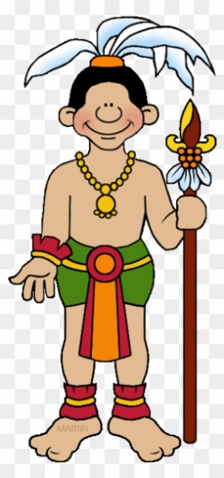 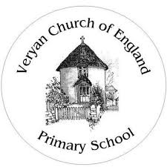

**Marvellous Mayans**

**Pendower Class**

**Essential Knowledge**

By the end of this unit the children will know…

* The chronology of the Mayan civilisation.
* Where the Maya were based.
* How the Maya became famous and impacted the future.
* How to create Mayan masks.
* Who the Maya worshipped.
* What daily life was like for a Mayan depending on their social status.
* What an archaeologist does and how their work has impacted what we know about the Maya.

**Nurture**

**Aspects of the topic which embody this value…**

**Eg:**

**Empathy**

**Caring for others**

**Raising money for charity**

**Understanding motives**

**Community**

**Engage**

**Aspects of the topic which embody this value…**

**Eg:**

**Gaining wisdom**

**Acquiring skills**

**Acquiring knowledge**

**Learning from mistakes**

**Thrive**

**Aspects of the topic which embody this value…**

**Eg:**

**Lived experiences**

**Thinking about our health etc**

**Making positive choices**

**Enjoying our school and home lives**

**Topic Celebration**

**Digital museum**

We will be creating a digital museum on Class Dojo.

This will include videos and pictures of artefacts created, as well as writing that the children have completed.

Children will be able to take their grownups at home through the digital museum and share their learning.



**History & Geography**

* Put together a timeline of the Mayan Civilisation.
* Understand how the Mayans impact us today (number system, calendar)
* Locate where the Maya come from.
* Understand what the Maya were able to grow and how the Geography of the land impacted that.
* Know who the Maya worshipped.
* Know what life was like for a Mayan, depending on their social status.

**Art and Design & Design and Technology**

* Create a Mayan mask.
* Examine the work of Frederick Catherwood and use elements in children’s own art work.
* Create a traditional Mayan dish using simple cooking techniques.

**Writing**

* Write instructions for a Mayan ball game.
* Write questions to be answered by an archaeologist.
* Explore Mayan folk tales and rewrite in the child’s own style.
* Respond to reading the Great Kapok Tree.
* Write setting descriptions based on Frederick Catherwood’s artwork.

**Spiritual**

* Judaism – How do the beliefs of Jews impact on the way that they act/ follow their religion?
* How is this similar or different to what Christians believe and the way that they follow God?

**Moral**

* Appreciate beliefs and ideas from other cultures.

**Mathematics**

**Number and place value –**

Children to use a range of manipulatives and visual methods to identify place value within a number.

**Number – Addition and Subtraction**

* Children to use manipulatives, building up to formal written methods to add and subtract numbers efficiently.

**Marvellous Mayans – Theme Content**

**Core Subjects**

**Personal Development**

**Foundation Subjects**

**Cultural**

* How do the work of archaeologists impact on our knowledge of the world around us?
* How did the Mayan civilisation move things forward?
* In what ways are things we do/ have now related back to Mayans?

**Social**

* Work together to complete their goals.
* Listen to, share and appreciate everyone’s thoughts and ideas.

**Computing**

* Use the internet to research the Mayan Civilisation.
* Use ICT to present work within English and topic lessons.
* Create a video as part of a presentation about the Maya.

**Music & Physical Education**

* Learn to play some of the Mayan ball games.
* Compare instruments from the Maya to instruments today.
* Listen to the type of music played in the Maya Civilisation and imitate.

**Science**

* Know the difference between and sort things into, a solid, liquid and gas.
* Observe physical changes when an item is heated or cooled and measure the point at which these changes take place.
* Know the words evaporation and condensation and be able to explain their meanings.



**Marvellous Mayans – Links to National Curriculum**

**Core Subjects**

**Foundation Subjects**

**Writing**

* Write simple, coherent narratives about personal experiences and those of others (real or fictional) (Y2)
* In narratives creates settings, characters and plot, with some ideas and material developed in detail and in non-narrative material, uses simple organisational devices. (Y3)
* Proposes changes to grammar and vocabulary, spelling and punctuation to improve consistency, including the accurate use of pronouns in sentences. (Y4)
* To spell using a combination of phonics, spelling patterns taught and common exception words learnt at their own level. (All years)

**Mathematics**

* Recognises the place value of each digit in a two-digit number (tens, ones). (Y2)
* Recognises the place value of each digit in a three-digit number (hundreds, tens, ones). (Y3)
* Recognises the place value of each digit in a four-digit number (thousands, hundreds, tens, and ones). (Y4)
* Solves problems with addition and subtraction using concrete objects and pictorial representations (Y2)
* Solves problems, including missing number problems, using more complex addition and subtraction. (Y3)
* Solves addition and subtraction two-step problems in contexts, deciding which operations and methods to use and why. (Y4)

**Science**

* Observing closely, using simple equipment (Y2)
* Making systematic observations using simple equipment (Y3)
* Making systematic and careful observations and, where appropriate, taking accurate measurements using standard units, using a range of equipment, (Y4)
* find out how the shapes of solid objects made from some materials can be changed by squashing, bending, twisting and stretching (Y2)
* compare and group materials together, according to whether they are solids, liquids or gases (Y3/4)

**History & Geography**

* Use aerial photographs, maps, atlases and globes and plan perspectives to recognize landmarks and basic human and physical features. (Y2)
* Use aerial photographs, maps, atlases, globes and digital / computer mapping to locate countries and identify features (Y3/4)
* Put things in order within the topic. (Y2)
* Order events over a larger timescale. (Y3)
* Beginning to think about the impact of historical events/people. (Y4)
* Know Language specific to topic (All years)
* Answer simple questions relating to the topic. (Y2)
* Children pose own questions to gain an understanding of the topic. (Y3)
* Generate purposeful questions. (Y4)

**Art and Design & Design and Technology**

* Begin to look at different artists’ work and attempt own interpretations of the style and technique(Y2)
* Explore shading with a pencil. (Y2)
* Introduce sculpture materials including clay and tools to create decorations on clay including engravers and embossing tools. (Y3)
* Manipulating clay using fingers and tools. (Y3)
* Begin to include elements of other artists work in their own. (Y3)
* Use pencils and pen work to create tone and shade and intricate marks when drawing. (Y4)
* Select and name appropriate tools and equipment needed. (Y2, 3, 4)
* Use knowledge of healthy eating to prepare dishes (Y2).
* Choose, prepare and cook dishes using some cooking techniques. (Y3, 4)

**Music & Physical Education**

* Create short musical patterns. (Y2)
* Effectively choose, order, combine and control sounds (Y3)
* Make creative use of the way sounds can be changed, organised and controlled (Y4)
* Understand basic tactics of a game (Y2)
* Begin to apply tactics and rules in a game (Y3)
* Apply and explain rules and tactics of a variety of games(Y4).

**Computing**

* Explore a website by clicking on the arrows, menus and hyperlinks .(Y2)
* Capture video. (Y2)
* Use a search engine to find a range of media e.g. images, text. (Y3/4)
* I can create video as part of my learning (Y3/4)