Planet poem
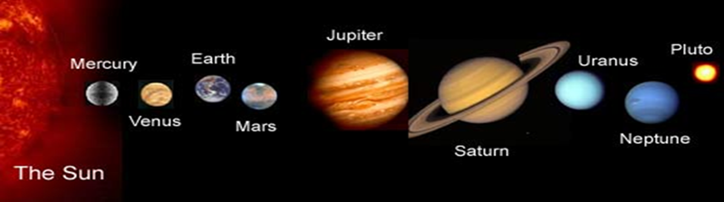

Welcome to the solar system! I’m the Sun
With eight planets around me, I will introduce everyone…

Marvellous Mercury
The Swift Planet they call me and I may be small
But in our solar system, I’m the fastest of all.

Vain Venus
I’m named after the goddess of love
Known for my brightness, I shine up above.

Excellent Earth
I am special, you can see
As people have chosen to live on me
My name means soil, I am no deity.

Magnificent Mars
Earth, I’m the opposite to you
My daytime sky is pink, my sunsets blue
One day my two moons will have to part
As my largest one, Phobos, will be torn apart.

Jubilant Jupiter
I’m the biggest and the best
With the shortest day I get plenty of rest.

Super Saturn
Jupiter may think it is best
But I have 82 moons, more than the rest
While the others may be round
I’m the flattest planet to be found.

Unique Uranus
The names of my moons are rather famous
Shakespeare’s characters and one from Pope
When you hear their names you should recognise them, I hope.

Noble Neptune
I’m named after the god of the sea
And one of my 14 moons is named especially for me
I’m the windiest planet that can be.

And so we are done
Have I missed anyone?
Pluto was here but we thought him too small
A tiny dwarf planet is hardly worth mentioning at all!

