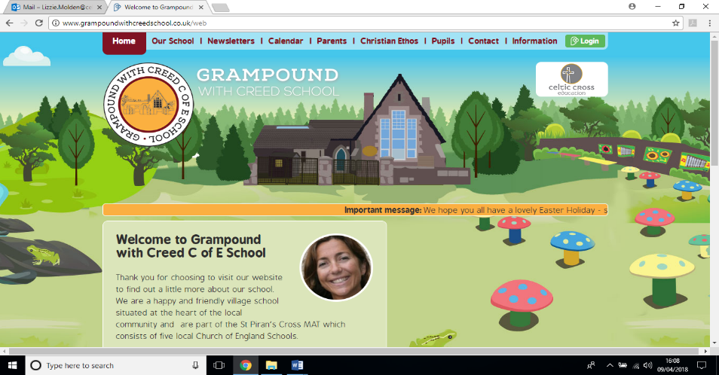

**My Cornwall, My Home**

**Pendower Class**

**Essential Knowledge / Skills**

By the end of this unit the children will know…

What is Cornwall famous for?

How has Cornwall changed over time?

How do we know about Cornwall in the past?

What impact did national changes have on Cornwall in the past?

RE - For Christians, what was the impact of Pentecost?

Science – Who are Cornish scientists and how have they impacted the world of science?

**Links to Christian values – compassion, perseverance, wisdom**

**Compassion**

**This term, Pendower will be focussing on compassion for those around them in learning about their local history. They will be putting themselves into the shoes of people of Cornwall throughout history whilst learning about their lives and experiences.**

**Perseverance**

**In our learning across the curriculum, we will be continuing to work on our growth mindset and our understanding of the way in which challenge helps us to grow in understanding, skills and knowledge.**

**Wisdom**

**Pendower will be showing and developing wisdom by using the learning strategies that they have developed so far this year to continue to flourish as learners in the final terms of the year and use wisdom to reflect on and understand what we need to do to reach our goals.**

**SMSC / British values links**

**British values**

**Tolerance and mutual respect – As children who have grown up in Cornwall, we will be learning about life for Cornish people over time and showing respect for their actions.**

**SMSC**

Spiritual and moral – Our focus on Pentecost this term will lead into children’s spiritual and moral development as we think about what it means to have the Holy Spirit with you and how that might impact our choices and actions.

Social – As we enter the final terms of the year, Pendower will be working on the strong social foundations that they have already made by working as a team to complete our stemterprise project and coming together to investigate Cornish history.

Cultural – Children will be learning about their own heritage and how the history of Cornwall has led to the Cornwall that we have today.

**Veryan School Topic Plan** 

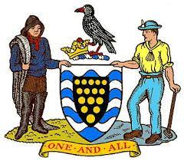



**Applied Maths**

* Our topic work will present opportunities for measuring, shape, statistics and position and direction.

**PE**

Focus – Striking and fielding

Including – rolling, throwing and striking a ball with accuracy, fielding and intercepting a ball to prevent runs by the opposing team.

Focus – Football

Including – travelling with, passing and receiving a ball in a competitive game. Playing as part of a team.

**Art & Design / Design Technology**

* This term we will be focusing on developing our knowledge of famous artists by focussing on Cornish artist Alfred Wallis. The children will develop a bank of drawings in the style of Alfred Wallis to include in their final piece of artwork.
* They will compare the style of Wallis’ landscapes to other artists who depict similar scenes and say what is similar/ different and what they prefer.

**RE Week - For Christians what was the impact of Pentecost?**

* This term in RE we will be answering the question For Christians, when Jesus left, what was the impact of Pentecost?
* This will involve us finding out about:
* The events of Pentecost
* The impact of Pentecost on the way that Christians worship now.
* What the Holy spirit means to Christians and how they show that in worship.

**Computing**

* In the build up to hosting our farm shop, our computing continues from last half term, children will be using different applications to create accompanying work, such as digital instruction guides, packaging labels, recipe cards, flower poems, visual guides and adverts.

**Maths**

* Year 3 and 4 – Decimal White Rose unit
* Year 3 and 4 – Time White Rose Unit

**Music**

* This term Pendower will be:
* Finding out about about traditional Cornish music
* Taking part in singing and performing a variety of traditional Cornish songs
* Reflecting on the importance of music within Cornwall’s past in relation to work life as well as wider society.

**History**

Over the course of the next 2 half terms, Pendower will be looking into Cornish History and Geography. We will begin by creating a timeline of Cornwall since the Neolithic Era and then work to add significant people and events to the timeline, stopping to delve deeper inti the associated historical and geographical consequences and developments.

**Reading / Key Texts**

**The Mousehole cat by Antonia Barber**

**An assortment of Cornish stories Retold by Donald R. Rawe including: The Piskey – led boy**

**Why the Whales came – Michael Morpurgo**

**Writing**

This term we will be learning to retell a traditional Cornish story. We will unpick the story including writing setting descriptions and adding detail to the story and then adapting the story to create our own traditional Cornish stories. Children will be focussing on writing stories with a beginning, build up, problem, resolution and ending. They will learn to use dialogue, paragraphs and ambitious vocabulary to make their stories captivating for the reader.

In addition, we will be writing non-fiction texts including chronological and non-chronological reports.

**Science – Famous scientist – linked to Cornwall topic**

This term our science will be influenced by our topic. We will be finding out about the scientific discoveries that have occurred in Cornwall and how science and technology enabled the movement of industry in Cornwall. This will lead to us learning about significant individuals in science and building on and using in context, our understanding of materials and their properties, rocks and light.

**Foundation Subjects**

**Non topic based**

**My Cornwall, My Home – Theme Content**

**Core Subjects**



**My Cornwall, My Home – National Curriculum**

**Core Subjects**

**Foundation Subjects**

**Writing**

Year 2 - consider what they are going to write before beginning by: planning or saying out loud what they are going to write about, writing down ideas and/or key words, including new vocabulary, encapsulating what they want to say, sentence by sentence.

Year 3 and 4 - draft and write by: composing and rehearsing sentences orally (including dialogue), progressively building a varied and rich vocabulary and an increasing range of sentence structures (English Appendix 2), organising paragraphs around a theme, in narratives, creating settings, characters and plot, in non-narrative material, using simple organisational devices [for example,headings and sub-headings], using and punctuating direct speech

**Reading / Key Texts**

**The Mousehole cat by Antonia Barber**

**An assortment of Cornish stories Retold by Donald R. Rawe including: The Piskey – led boy**

**Why the Whales came – Michael Morpurgo**

**Applied Maths**

Year 2 choose and use appropriate standard units to estimate and measure length/height , mass (kg/g); temperature (°C); capacity (litres/ml) , compare and sort common 2-D and 3-D shapes and everyday objects, use mathematical vocabulary to describe position, direction and movement, ask and answer questions about totalling

and comparing categorical data.

Year 3 measure, compare, add and subtract: lengths, mass, volume/capacity, recognise angles as a property of shape or a description of a turn, interpret and present data using bar charts, pictograms and tables

Year 4 estimate, compare and calculate different measures, including money in pounds and pence, identify acute and obtuse angles and compare and order angles up to two right angles by size, describe movements between positions as translations of a given unit to the left/right and up/down, interpret and present discrete and continuous data using appropriate graphical methods, including bar charts and time graphs.

**History**

Year 2 – children should be taught about significant historical events, people and places in their own locality.

Year 3 and 4 – children should undertake a local study, including: - A study over time tracing how several aspects of national history are reflected in the locality (this can go beyond 1066)

A study of an aspect of history or a site dating from a period beyond 1066 that is significant in the locality.

**Art and Design / Design and Technology**

Year 2 - to use drawing, painting and sculpture to develop and share their ideas, experiences

and imagination, to develop a wide range of art and design techniques in using colour, pattern, texture,

line, shape, form and space, about the work of a range of artists, craft makers and designers, describing the differences and similarities between different practices and disciplines, and making links to their own work.

Year 3 and 4 - to create sketch books to record their observations and use them to review and revisit ideas, to improve their mastery of art and design techniques, including drawing, painting and sculpture with a range of materials [for example, pencil, charcoal, paint, clay], about great artists, architects and designers in history.

**RE Week**

Make sense of belief:

• Make clear links between the story of Pentecost and Christian beliefs about the ‘kingdom of God’ on Earth

• Offer informed suggestions about what the events of Pentecost in Acts 2 might mean

Give examples of what Pentecost means to some Christians now

Understand the impact:

• Make simple links between the description of Pentecost in Acts 2, the Holy Spirit, the kingdom of God, and how Christians live now

• Describe how Christians show their beliefs about the Holy Spirit in worship

Make connections:

• Make links between ideas about the kingdom of God in the Bible and what people believe about following God today, giving good reasons for their ideas.

**Science**

Year 2 - identify and compare the suitability of a variety of everyday materials, including wood, metal, plastic, glass, brick, rock, paper and cardboard for particular uses, find out how the shapes of solid objects made from some materials can be changed by squashing, bending, twisting and stretching

Year 3 and 4 - compare and group together different kinds of rocks on the basis of their appearance and simple physical properties, recognise that they need light in order to see things and that dark is the absence of light

**Non Topic Based**

**Maths - White Rose Coverage**

* Year 3 and 4 – Decimal White Rose unit
* Year 3 and 4 – Time White Rose Unit

**Music**

Year 2 - use their voices expressively and creatively by singing songs and speaking chants and rhymes

Year 3 and 4 - play and perform in solo and ensemble contexts, using their voices and playing musical instruments with increasing accuracy, fluency, control and expression

* develop an understanding of the history of music.

**PE**

Year 2 - master basic movements including running, jumping, throwing and catching, as well as developing balance, agility and co-ordination, and begin to apply these in a range of activities

Participate in team games, developing simple tactics for attacking and defending

Year 3 and 4 - use running, jumping, throwing and catching in isolation and in combination

Play competitive games, modified where appropriate and apply basic principles suitable for attacking and defending

**Computing**

Year 3 and 4 - Select, use and combine a variety of software (including internet services) on a range of digital devices to design and create a range of programs, systems and content that accomplish given goals, including collecting, analysing, evaluating and presenting data and information.