Year 1 & 2 Enhanced PE Curriculum
W/B Mon 8th March 2021 – Easter Holidays.
Aim: To provide pupils with fun and engaging PE lesson which enables them, on their return to school to specifically focus on: working safely, following instructions, teamwork, communication and social skills.
Week | Lesson Content | PSHE Focus questions
1 | Warm up (10-15 mins)  Fundamental movement skills: jogging, walking, side steps, hopping, jumping. Thinking about space and using their eyes and ears when moving around. When Teacher calls freeze can children stop a space in the READY position (see below). Teacher can give them a little push to see if they are tight and strong in their core (they love this and think it is hilarious).  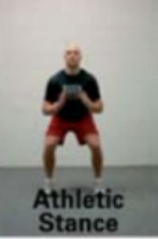  Content  - Relay activities in teams of 4. Jogging, collecting cones, obstacle courses. Move the winning team further apart each time or away from the cones etc.  - Bean Game  Command Action  JUMPING BEAN Jump around the room  RUNNER BEAN Run around the room (looking out for other people).  OR Running on the spot (more suitable for younger children than running around the room)  BROAD BEAN Stretch your arms and legs out as wide as you can.  Walk around the room taking as large strides as possible  Jump in a star shape  BAKED BEAN Lay on the floor in a star shape until the next command is given.  OR Lie on floor and Sunbathe  JELLY BEAN Move around the room slouching and doing silly movements  Wobble like a jelly  CHILLI BEAN Shiver and shake  FROZEN BEAN Children have to stand very still.  MR. BEAN Walk around with a puzzled/vacant expression, muttering under your breath!  Plenary  Q&A, Pair and Share  Can you name some the movements you did today? How did your body feel? Can you see anyone with a red face? Why would it be red? | Introducing physical activity and creating a safe space  Key Questions  • What does physical activity mean? • What types of activities are physical?  Key Messages  Children and young people should: • Aim for an average of at least 60 minutes of physical activity a day across the week. • All activities should make you breathe faster and feel warmer.
2 | Warm up (10-15 mins)  Fundamental movement skills: jogging, walking, side steps, hopping, jumping. Thinking about space and using their eyes and ears when moving around. When Teacher calls freeze can children stop a space in the READY position (see week 1). Teacher can give them a little push to see if they are tight and strong in their core (they love this and think it is hilarious).  Content  - Bridges Game: pupils are walking around, jogging around, skipping, jumping, and hopping (initial assessment of pupil’s techniques). On the command BRIDGES – pupils find a partner to make a bridge with (palm flat against one another, fingers pointing up to the sky, feet flat on the floor). Teacher chooses a pair to run under as many bridges as they can in 10 seconds. Class can count down from 10 (Numeracy link) or up to 10!  - Pirate Game. Teacher splits class into 4 teams with a treasure chest in the middle filled with cones (treasure), each route into get the balls is a slightly different obstacle course. Progressions: A) everything is worth one point. B) Different points for different items/colours C) Rotate pupils around different courses. NON-CONTACT, ONLY 1 PERSON CAN RUN AT A TIME FROM EACH TEAM, ONLY 1 ITEM AT A TIME!  https://kiddo.edu.au/activities/rob-nest-catching  Plenary  Q&A, Pair and Share  What did your team do well? Why did you do it well? Who do you think worked really well in your team? Why? What does it mean to win/lose? Teacher to identify what positive behaviours they observed. | What sort of activity should we be doing?  Key Questions  • How do you feel when you go for a long walk? What about a run? Discuss different intensity of exercise and link to how it affects the body. Discuss at the start of lesson – how do they feel? During the warm-up. Has it changed? Why?  • Which physical activities have you done this week?  Key Messages  • Moderate intensity activities will raise your heart rate, and make you breathe faster and feel warmer. • One way to tell if you are working at a moderate intensity level is if you can still talk, but not sing.
3 | Warm up (10-15 mins)  Bean Game  Command Action  JUMPING BEAN Jump around the room  RUNNER BEAN Run around the room (looking out for other people).  OR Running on the spot (more suitable for younger children than running around the room)  BROAD BEAN Stretch your arms and legs out as wide as you can.  Walk around the room taking as large strides as possible  Jump in a star shape  BAKED BEAN Lay on the floor in a star shape until the next command is given.  OR Lie on floor and Sunbathe  JELLY BEAN Move around the room slouching and doing silly movements  Wobble like a jelly  CHILLI BEAN Shiver and shake  FROZEN BEAN Children have to stand very still.  MR. BEAN Walk around with a puzzled/vacant expression, muttering under your breath!  Content  - Freeze and Thaw Game. Discuss types of balances that we can do with our bodies – one leg, two hand one leg two legs one hand or bottom etc. Similar to what is the time Mr Wolf? Teacher or child stands at one end of the playground with back to class. When back is turned away from class the class can creep forward (thawing out). When child or teacher turns around the class freeze in a balance of their choice. If there are, enough adults play 2 games. Identify good shapes/balances.  - Rollerball Game. Divide children into 4 small groups. They sit in 4 lines as shown below. Teacher and adults sit in-between the 2 lines with two cones each side of them with two small balls one in each hand. There will be 2 games going at once. Teacher rolls the ball; first child in the line runs to collect the ball and has to place it on the cone. Once child has retuned, next child in line goes. And so on.  Can be completed as competition or just for hand eye coordination practice.  Emphasis on keeping their eye on the ball, collect with hands, staying on their feet.  SAFETY POINTS/RULES: Do not stand up until there is a ball on the cone in front of you, always stay on your feet, and use your eyes/ears to make sure you do not run into anyone.  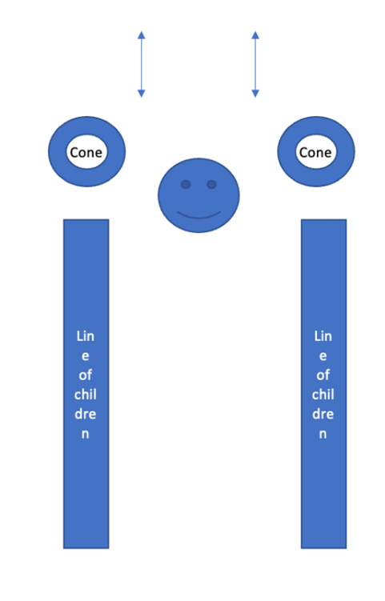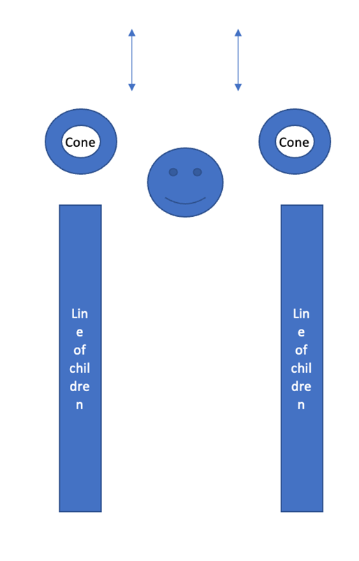  Plenary  Q&A, Pair and Share  What did we learn today? Who do you think worked really well in your team? Why?  Teacher to inform them how we will use this moving forward.  Teacher to identify what positive behaviours they observed. | Why is physical activity so important?  Activity  • Ask the children to think about why physical activity is so important. • Initially they may focus on the health benefits.  * Builds confidence *social skills *Improves concentration * Improves co-ordination  *Improves sleep *Helps maintain a healthy weight *Makes you feel good • Take suggestions from the children. Key Questions  Key Messages  • Physical activity is important for our physical health however, it also supports our wellbeing. Taking part in physical activities can help build friendships and connect us with other people.
4 | Warm up (10-15 mins)  Split the group into 6 or 8 teams. Choose a leader in each team to lead their team in a warm-up. Remind them of pulse raining activities they can do.  Content  - Roll it: In pairs standing 2 metres apart. Child A rolls the ball with two hands, aiming for their partner. More able: Move further away/use various balls. Less able: Move closer together.  - Tunnels (Two hands): In pairs standing 2 metres apart. Child A rolls the ball with two hands, aiming to get it through their partner’s legs (the tunnel) and then runs to collect it before setting up again. Teacher can ask children to demonstrate good examples. More able: Move further away/use various balls. Less able: Move closer together.  CHALLENGE: Tunnels (one hand – ONLY FOR MA) In pairs standing 2 metres apart. Child A rolls the ball with one hand, aiming to get it through their partner’s legs (the tunnel).  - Rollerball Game (see last week for explanation).  Plenary  Plenary  Q&A, Pair and Share  What did we learn today? Who do you think worked really well in your team? Why?  Teacher to inform them how we will use this moving forward.  Teacher to identify what positive behaviours they observed. | Summary  • Recap the main messages from the lesson.  • We all need regular physical activity to keep us healthy.  • Physical activity also has other benefits.  • Children should have 60 minutes of physical activity per day.  • Activity is either light, moderate or intensive.

