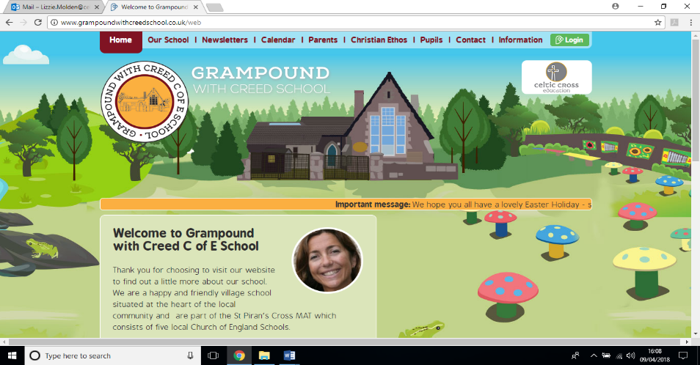

**South Ameica**

**Kiberick Class**

**Essential Knowledge / Skills**

By the end of this unit the children will know…

* The names and location of the largest countries in South America: Brazil, Peru, Argentina, Columbia, Venezuela and Bolivia
* The dominant religion and cultural identity of Brazil and Peru
* Cultural traditions of carnival and music in Brazil
* The main geographical features of South America and begin to appreciate the importance of this region of the world for the climate of the whole world.
* How plants and animals process water and nutrients

**Links to Christian values – compassion, perseverance, wisdom**

**Compassion**

**Showing compassion for the plight of others in this world who are not fortunate enough to have secure shelter and food. The inequalities that still exist in societies across the world.**

**Perseverance**

**The art and design and design technology activities will prove very demanding as we are trying to refine technique in using tools and a greater variety of materials to construct masks and instruments with a practical purpose.**

**Wisdom**

**Examining myths and legends will allow an opportunity to gain wisdom from literature and ancient times as well as other cultures.**

**SMSC / British values links**

**Respect and Tolerance**:

* Becoming more familiar with people of different cultures and faiths
* Being able to listen to the opinions and beliefs of others to gain a greater understanding and awareness
* Respecting the beliefs of others whilst also disagreeing and without feeling the need to change another person’s beliefs.
* Showing tolerance for the opinion and actions of others

**Veryan School Topic Plan** 

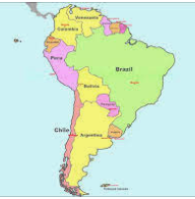



**Computing : Video**

Film dance routines made in PE & their live Carnival dance and export to You Tube or Class Dojo

Create an animation based on the journey of water and nutirents

**Science Week**

* . Y6 Animals- circulation & transportation of nutrients and water

Look at diagrams of the internal organs and mechanisms inside the human body to trace the journey of water and food.

Look at diagrams of trees to trace the journey of water and nutrients. Conduct experiments using dye to show this journey in plants. Examine growth rings in tree trunks

Link to main topic : What happens when humans or trees do not get enough water or nutrients ?

**RE Week**

**Unit U2.11 Why do some people believe in God and some people not ?**

Debate ideas about ‘God’ as a divine being or all powerful force.

Explain their own beliefs and the reasons for this.

Explore some of the other groups of people who do not believe in God – why and what, if anything , they do believe in.

**Art & Design / Design Technology**

* Creating carnival masks
* Designing and building musical percussion instruments as in a Samba band.

**Geography**

* Become familiar with the map of South America, key facts and flags
* To explore the culture of Brazil and Peru, comparing them to each other and the UK
* To explore some of the geographical features of these countries: Machu Pichu, The Andes, Amazon Rainforest (This topic will overlap into next half term’s topic of Climate Zones

**MFL**

French: single weather words and clothes building to be able to have a simple conversation using whole sentences about the weather in French and in writing. Whilst also repeating previous vocabulary.

**Maths - White Rose Coverage**

Y5 & 6 , Fractions: equivalence, improper, ordering, adding.

Y6: Decimals 3dp, decimals as fractions, percentages, simple algebra, 2 step equations

**PE**

Dance – composing dance routines in the style of carnival routines.

.

Sailing

**Writing**

* Examining the features and conventions of myths and legends
* Writing legends
* Information texts: continuing to explore a variety of ways of arranging information for different functions
* Grammar: tenses and verb forms

Grammar: using clauses to expand the detail within single sentences and their own free writing.

* Spelling: continuing the very successful approach of using topic related vocabulary for weekly spelling ‘tests’
* Spelling: the rules for adapting words as plurals

**Reading / Key Texts**

* **Mythopedia – a source book of mythological beasts taken from across the Americas. The mythical beast stories illustrate or echo cultural and religious beliefs from across the region and provide an insight into both.**

**Music**

Percussion instrument: Improvising with Instruments (Dynamics, Tempo, Timbre and Texture) in the context of Samba music

**Foundation Subjects**

**Non topic based**

**South America – Theme Content**

**Core Subjects**

**Applied Maths**

Applied maths will be mainly connected with the Design Technology tasks and will involve-

* Accurate measuring
* Using a protractor and compass effectively
* Calculating volume



**South America – National Curriculum & Skills progression**

**Core Subjects**

**Foundation Subjects**

**Writing**

* using passive verbs to affect the presentation of information in a sentence ♣ using the perfect form of verbs to mark relationships of time and cause ♣ using expanded noun phrases to convey complicated information concisely
* using relative clauses beginning with who, which, where, when, whose, that or with an implied (i.e. omitted) relative pronoun

**Reading / Key Texts**

* increasing their familiarity with a wide range of books, including myths, legends and traditional stories, modern fiction, fiction from our literary heritage, and books from other cultures and traditions

**Applied Maths**

* know angles are measured in degrees: estimate and compare acute, obtuse and reflex angles ♣ draw given angles, and measure them in degrees (o )
* estimate volume [for example, using 1 cm3 blocks to build cuboids (including cubes)]

**History / Geography**



**Art and Design / Design and Technology**

* Pupils should be taught to develop their techniques, including their control and their use of materials, with creativity, experimentation and an increasing awareness of different kinds of art, craft and design.
* to improve their mastery of art and design techniques, including drawing, painting and sculpture with a range of materials [for example, pencil, charcoal, paint, clay] use research and develop design criteria to inform the design of innovative, functional, appealing products that are fit for purpose, aimed at particular individuals or groups

**RE Week**

**Unit U2.11 Why do some people believe in God and some people not?**

This is a thematic unit comparing religious and non-religious responses to the idea of God. It builds on pupils’ earlier learning about God in Judaism, Christianity and Islam – three monotheistic traditions with common roots. Y6 is a good place to do this, as it consolidates prior learning but also allows pupils to express their own ideas too. The unit focuses on ideas and answers from Christians about belief in

God The unit question is open, and there are many different reasons people give for their beliefs about God.Non-religious responses are diverse and it is important not to present Atheists as a single group, or agnostics as a group – these categories encompass a wide range of beliefs. Humanists are only one example of people who are atheists, and Humanist beliefs vary too.

**Science Week**

* Y6 Animals- circulation & transportation of nutrients and water
* Describe the ways in which nutrients and water are transported within animals, including humans
* The other elements of Animals (bodies and exercise) will be covered in summer term alongside sports day and SRE

**Non Topic Based**

**PE**

**Sailing for some children.**

**Multi-skills to support competitive games once we are allowed.**

**Dance movements and routines for carnival**

**Computing**

**Video**

Storyboard and capture video for a purpose

Plan for the use of special effects and transitions.

Trim, arrange and edit audio levels to improve quality of their outcome.

Export their video

**Animation:**Plan a multi-scene animation including characters, scenes, camera angles and special effects,Use stop-go animation software (Ican Animate/Hue animation) with an external camera to shoot animation frames.Adjust the number of photographs taken and the playback rate to improve the quality of the animation.Publish their animation and use a movie-editing package to edit/refine and add titles.

**Music**

Improvising with Instruments (Dynamics, Tempo, Timbre and Texture)

**MFL**

* engage in conversations; ask and answer questions; express opinions and respond to those of others; seek clarification and help*
* speak in sentences, using familiar vocabulary, phrases and basic language structures