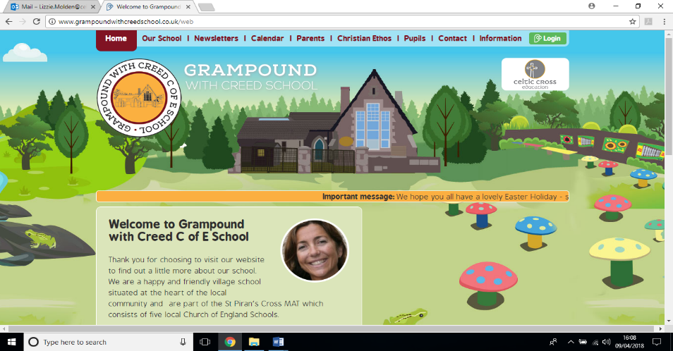

**Let’s take a walk on the wild side !**

**Carne Class**

**Essential Knowledge / Skills**

By the end of this unit the children will know…

-to group living things according to similarities and differences. Sc2 4b

-to care for the environment Sc2 5

to recognise how places compare with other places Geog 3c

-to express their own views about people places and environments Geog 1c

-identify what places are like Geog 3a

-identify and describe where places are Geog3b

-recognise changes in physical and human features Geog 4b

-recognise changes in the environment Geog 5a

how sounds can be made different ways Music 4c

- to explore ad express their ideas and feelings about suing music using movements and dance and expressive musical lang Music 3a

To design and create to achieve a planned effect.

To recognise that Christians believe that God created the world and would like us to take care of it and each other.

**Links to Christian values – compassion, perseverance, wisdom**

**Compassion**- We will think deeply about what it feels like to make a mistake or take a bad choice and the consequences of this. We will discuss and practice being compassionate towards one another in good times and bad and how we are learners and we are expected to make mistakes and come back from them with the help of our friends and teachers.

**Perseverance-** We will challenge ourselves physically and mentally and experience what it is like to persevere at a skill over a period. We will monitor and celebrate our progress and reflect on the process and the perseverance it took to get where we are

**SMSC / British values links**

**Democracy-** I can influence my lessons and my experiences in class by sharing my ideas and responding.

**Respect**- I will listen to others, as I would like to be listened to

**Law-** I understand that the school rules mirror society law and must be respected. I learn about choices and consequences through trial and error and through time in with a grown up when I make a mistake

**Responsibility**- I have a responsibility to do the best I can each day and engage in lessons and school life. I am responsible for my own actions.

**Veryan School Topic Plan** 

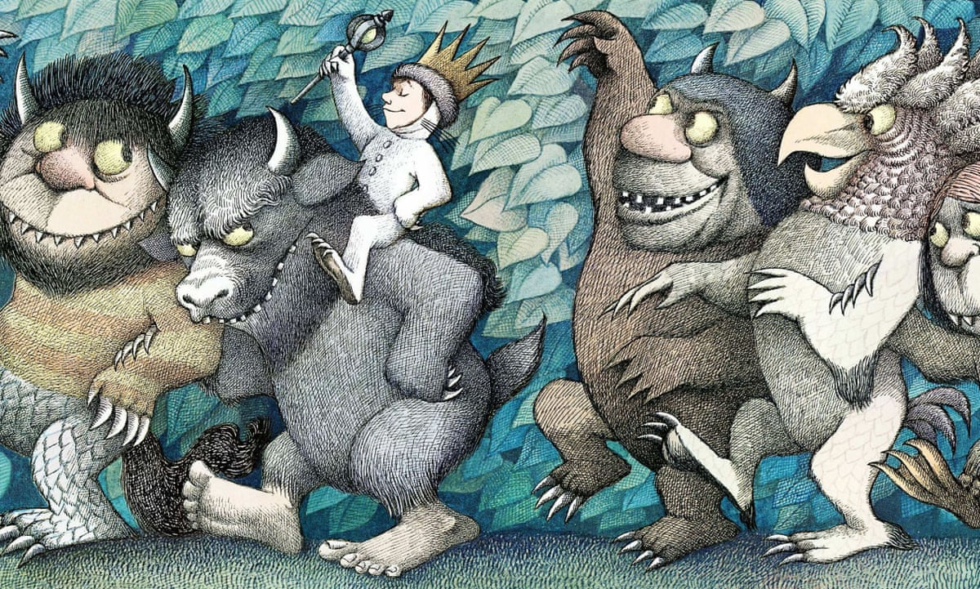



**Writing**

* Daily Phonics activities to support use of taught graphemes
* Hold a sentence, complete a sentence and unscramble the sentence activities
* If I was a wild thing creative writing
* Draw and describe your own wild thing using wow words
* Write a fact sheet about the rainforest
* Explore verbs – list all the things the wild things ‘do’
* Writing lists of thig s to take to an island

**Reading / Key Texts**

* Where The Wild Things Are
* Rainforest and wild animal fact books
* Songs and Rhymes- Walking through the jungle
* I dig My Garden
* Mary Mary Quite Contrary, How does your Garden Grow ?
* 2x per week reading of scheme reading books and daily book time and storytelling

**Computing**

**Graphics**

Use ICT to generate ideas for their work.

Use various tools such as brushes, pens, rubber, stamps, shapes.

Save retrieve and print work.

**PE**

Dance – Miss Katie I can follow a sequence of movements. I can move with rhythm to music.

Climbing up and down large climbing apparatus safely

 I can navigate how to get on and off a swing and make it move using the weight of my body

I can talk about what makes a healthy lifestyle and the things I need to keep me feeling safe, happy and healthy- link to mental health awareness week.

Riding balance bikes and scooters and learning to skip.

**Music**

Know how sounds are made and changed.

Use voice in different ways to create different effects.

Make a sequence of long and short sounds with help (duration).

Clap longer rhythms with help.

**Maths - White Rose Coverage**

Number recognition and number formation

Counting in 2’s 5’s and 10’s

Multiplication and division

**Science Week**

* Looking at life cycles
* Caring for the natural environment
* Identifying the characteristics, similarities and differences of each of the 5 groups of mammals
* Recognise the difference between omnivores, herbivores and carnivroes by trying out a range of foods from each group

**RE Week**

* Being special
* Who do Christians say made the world
* How we can take care of ourselves, each other and the world we live in

**Art & Design / Design Technology**

* Create collage stick puppets of wild things ,
* Leaf and bark rubbings from a local wild space
* Explore colour and texture in nature
* Colour by numbers wild animals

**Foundation Subjects**

**History / Geography**

* Comparing rural environments and wild spaces to suburban ones
* Finding out where the biggest forests are in the world and the creatures that live there, comparing them to woodlands and wild spaces in our local area
* Visit the rainforest using the VR headset from The Tree Champion scheme

**Non topic based**

**Let’s take a walk on the Wild Side! – Theme Content**

**Core Subjects**

**Applied Maths**

* Days of the week
* Months of the year
* Counting how many are here today
* Snack time orders
* Multiplying to find how many treats we will need in Friday club



**Let’s take a walk on the Wild Side! – National Curriculum & Skills progression**

**Core Subjects**

**Foundation Subjects**

**Writing**

To recognise consonant digraphs which have been taught and the sounds which they represent.

To recognise vowel digraphs which have been taught and the sounds which they represent.

To recognise words with adjacent consonants.

To accurately spell most words containing the 40+ previously taught phonemes and GPCs.

To spell some words in a phonically plausible way, even if sometimes incorrect.

* ‘n’ before ‘k’ (e.g. bank, think);
* dividing words into syllables (e.g. rabbit, carrot);

**Reading / Key Texts**

To apply phonic knowledge and skills as the route to decode words.

To blend sounds in unfamiliar words using the GPCs that they have been taught.

To respond speedily, giving the correct sound to graphemes for all of the 40+ phonemes.

* To read words containing taught GPCs

**Applied Maths**

* I can tell you what day of the week it is
* I can work out practical problems involving division and multiplication for example when sharing fruit and snacks or sharing out resources
* I know what the symbols for division and multiplication mean.

**History / Geography**

* I can identify the natural /wild paces in my local environment
* I can name and identify some features of a local suburban area
* Know the similarities and differences from one small area of the UK
* Use some key vocabulary to describe features of the environment. (e.g. beach, cliff, coast, city, town, village).
* Use directional language (left or right, near or far).
* Use simple fieldwork and observational skills to study geography of the school grounds.

**RE Week**

* I can talk about Christianity as a religion and a belief system.
* I begin to formulate my own opinions and understand that they may differ from other people
* I know that Christians believe God made the world
* I can explain why and demonstrate how we can take care of the natural world

**Science Week**

* I know what living things need to help them to grow
* I can identify man-made and natural materials and understand why some man- made materials might be harmful to the natural world
* I can identify mammals including humans.
* I can describe the lifecycle of a human

**Non Topic Based**

**PE**

Link two or more actions together. Perform some simple dance moves.

 Demonstrate rhythm and control.

Make a sequence.

Agility balance and coordination activities – climb stairs while holding something in 2 hands.

 Balance for short periods on a 2 wheel balance bike, turn and stop with control.

Jump and land on two feet with control. Be aware of the space around me and any obstacles

**Music**

I can identify some musical instruments that I hear

I can describe how a piece of music makes me feel

**Computing**

I can use an age appropriate programme to create pictures and text documents

I can save my work and find, retrieve and print it with the help of adult

**Maths - White Rose Coverage**

Solve one-step problems involving multiplication and division using concrete objects and arrays with the support of the teacher.