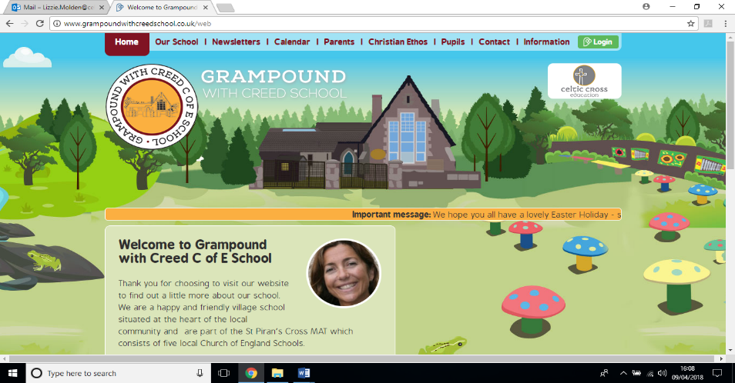

**Real life Heroes**

**Essential Knowledge / Skills**

By the end of this unit the children will know…

Children will learn about their own uniqueness and about their own and each other’s personalities.

<https://www.hamilton-trust.org.uk/topics/reception-topics/superheroes/im-superhero/>

Children will learn about how they can help one another and how other real life heroes such as firefighters, the police, nurses, doctors and other service people help us.

During Science Week children will explore the four seasons and observe, describe and record the weather. They will also explore the properties of different materials and be able to distinguish between what an object is and the material it is made from. They will decide on what makes a material useful for a particular purpose.

**Links to Christian values – compassion, perseverance, wisdom**

Compassion:Children will learn about one another and what makes each of us unique including the things we are good at and the things we find challenging. We will explore ways that we can encourage one another and support each other in our learning

Perseverance: We will experience many new activities, some of which we may find challenging.

Wisdom: Children will observe nature and wonder at the wisdom of animals preparing for the winter.

**SMSC / British values links**

* Democracy- working as part of a whole school team, making decisions collaboratively within our classes
* The rule of law- learning how rules keep us and others safe
* Individual liberty- being given the time and space to express ideas and feelings in a supportive environment
* Mutual respect for and tolerance of those with different faiths and beliefs, and for those without faith.

**Veryan School Topic Plan** 



**Writing**

* N/R Writing labels and captions including my name.
* Year 1 Writing sentences
* Rhyming words

**PSHE**

* Learn each other’s names
* Learn school routines
* Identify what makes you a real life superhero
* Encourage each other to use our superpowers for good

**PE**

Children will play arrange of games that involve moving safely around a space, avoiding obstacles, moving at different speeds and following 2 and 3 step instructions .

**Art & Design / Design Technology**

* Create a self portrait
* Create an Autumn collage
* Explore with paint and mixing colours as well as different ways of applying paint to various media

**History / Geography**

* This topic does not lend itself to History and Geography coverage so these will be addressed in other topics throughout the year.

**RE**

Learning about our school family

Our values and mission

The things that are important to us

The meaning of the words compassion, perseverance and Wisdom

Becoming a united team

Learning about one another and our personalities including our similarities and differences.

Working together

Classroom rules and how we can look out for one another

**Science Week**

* Seasons (N and R) and materials (year 1/2 )

<https://www.hamilton-trust.org.uk/topics/key-stage-1-topics/weather-experts/seasonal-change/>

<https://www.hamilton-trust.org.uk/science/year-12-science/brilliant-builders/>

**PE**

Year 1: Show control and coordination when travelling and balancing.

Nursery/ Rec: Show control when travelling,

Move confidently in a range of ways

**Music**

Listen for different types of sounds (provide opportunities to listen to live music).

**Computing**

**Maths - White Rose Coverage**

Reception: Sorting and grouping objects- Year 1 recap

Reasoning and problem solving – how many ways can we sort these things ?

Bead string grouping and counting , tens and ones

Count to, back and across 100

Count in steps of 2,4,10

**Non Topic Based**

**Reading / Key Texts**

* You’ll soon grow Alex
* Peace at last
* Five minutes Peace
* Superkid
* SuperHeros don’t get scared

**Music**

Learn new songs and rhymes

Move rhythmically to music

Join in with known songs and rhymes

**Computing**

Using the interactive whiteboard to create our own pictures.

**Maths - White Rose Coverage**

Start of term baseline assessments

Maths games and activities

White Rose Unit Number and Place Value (year 1/2)

Nursery/ Reception- recognising numbers, counting and sorting

**Foundation Subjects**

**Non topic based**

**Real life Heroes– Theme Content**

**Core Subjects**

**Applied Maths**

* Days of the week
* Months of the year/ seasons
* Counting how many are here today
* Snack time orders



**Real life Heroes– National Curriculum & Skills progression**

**Core Subjects**

**Foundation Subjects**

**Writing**

* N/R Writing labels and captions including my name.
* Year 1 Writing sentences using a capital letter at the beginning and for names and a full stop at the end.

**Reading / Key Texts**

* **The Great Big Book of Families**
* **Various fact books on job roles**
* Peace at last

Five Minutes Peace

Understand the five key concepts about print:

print has meaning

the names of different parts of a book

* print can have different purposes
* page sequencing
* we read English text from left to right and from top to bottom

**Applied Maths**

* Recognise which day of the week it is

Count 1:1 and know that the last number is the total. Say the days of the week in order.

**History / Geography**

* This topic does not lend itself to History and Geography coverage so these will be addressed in other topics throughout the year.

**Art and Design / Design and Technology**

* Explore what happens when mixing colours
* Manipulate materials to achieve planned effect.
* Explore a variety of materials.
* Use materials creatively to design and make products.
* Use drawing, painting and sculpture with different materials.
* Malleable materials such as clay and dough.
* Explore and understand the impact of materials including hard and soft pencils, wet and dry paper, paint and ink.
* Use a range of textile equipment including beads and fabric/thread for sewing.
* Malleable materials.

**RE**

* Children express their ideas and opinions about God and Christianity.
* Children are confident to try new activities, and say why they like some activities more than others do. They are confident to speak in a familiar group, will talk about their ideas, and will choose the resources they need for their chosen activities.

**Science**

* compare and group together a variety of everyday materials on the basis of their simple physical properties
* observe and describe weather associated with the seasons and how day light length varies

**Maths - White Rose Coverage**

EYFS: Subitising – counting forwards to 10

Year 1: Representing numbers to 10

Year 2: Representing numbers to 50

**Computing**

Using the interactive whiteboard to create our own pictures.

**Music**

Learning class songs, prayers and rhymes.

Move to music

Clap rhythms

Express likes and dislikes

**PE**

Children will play arrange of games that involve moving safely around a space, avoiding obstacles, moving at different speeds and following 2 and 3 step instructions .