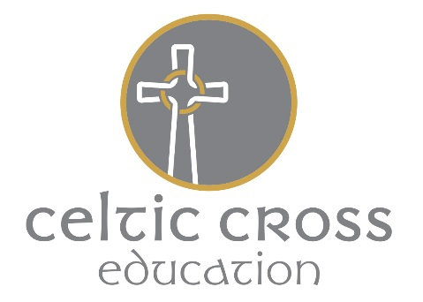

Local Roles and Responsibilities for Health and Safety
Veryan C of E school

School Monitoring Council (SMC)
The SMC of each school in the MAT are responsible for ensuring that mechanisms and procedures are in place for health safety and welfare. The SMC will receive regular reports to enable them, in collaboration with the Head/Principal, to prioritise resources for health safety and welfare issues.
The SMC for this school have appointed a Safety Councillor to receive information, monitor the implementation of policies, procedure and decisions and feed back to the Governing Body on health safety and welfare issues.
The Safety Councillor for this school is Janet Webb

Senior Management/Heads
Senior management/Heads have responsibilities for:-
- Day-to-day management of health safety and welfare in accordance with the Health and Safety Policy;
- Drawing up and reviewing site procedures regularly;
- Ensuring that suitable risk assessments have been carried out for all activities where there is a significant risk;
- Carrying out regular(daily) inspections and making reports to the Business Manager and Principal when required;
- Ensuring action is taken on health safety and welfare issues;
- Notifying the central office of any highlighted employee training, information and instructions required;
- Passing on health safety and welfare information received to appropriate people;
- Acting on reports from employees, the Business Manager, Principal, the SMC and the Local Education Authority (current H & S support)

All Employees
All employees have a general responsibility, as far as reasonably practical, to ensure the health safety and welfare of themselves and others who may be affected by anything they do or fail to do. In particular employees have a responsibility for:-
- Checking that classrooms/work areas are safe;
- Checking equipment is safe before use;
- Ensuring safe procedures are followed;
- Ensuring protective equipment is used when needed;
- Participating in inspections and the Health and Safety Committee if appropriate;
- Bringing problems to the relevant manager’s attention.
In addition all employees have a responsibility to co-operate with the employer on matters of health and safety.

Volunteers
Volunteers (such as parent-helpers, etc.) have a responsibility to act in accordance with the Academy’s policies and procedures for health safety and welfare and to report any incident or defective equipment to a member of staff immediately.
Volunteers are also expected to act only under the supervision of a qualified employee.

