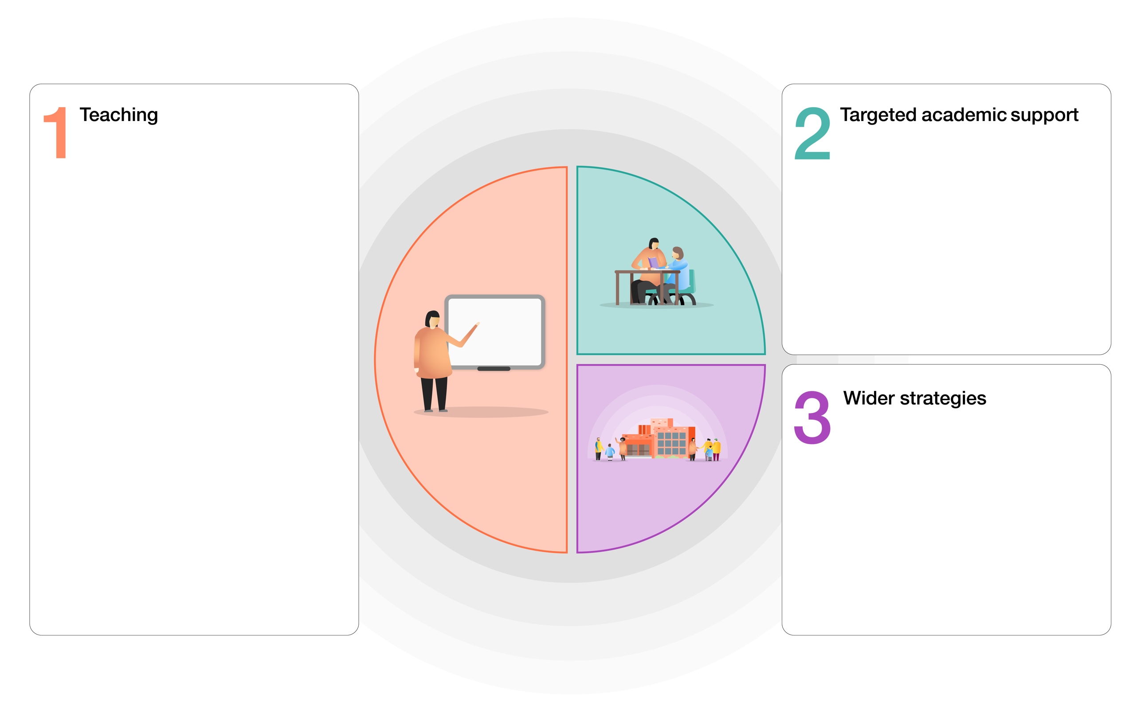

* Parent support advisor for families.
* Supported places for breakfast club including free breakfast & positive social experiences.
* TIS Nurture provision (both group / 1:1)
* Lego Therapy.
* Enhanced activities, trips and visits provision included places for camp.
* Wild Tribe / outdoor learning.
* Teacher enrichment clubs.
* Music tuition support.
* Free milk
* Teacher / HLTA led interventions including RWI phonics / reading / writing, maths mastery, pre teach, precision teaching, memory building and Fun Fit. Guided reading / writing groups.
* Use of ICT based resources; Spelling Shed, Sumdog, Times Tables Rockstars.
* Whole school TIS approach for emotional support.
* Whole school implementation of Growth Mindset approach to support metacognition and self-regulated learning.
* Reading for pleasure whole school approach.
* Adoption of whole school teaching approaches- RWI phonics / reading / writing. Let’s think in English, Alan Peat sentence building, Literacy Shed, Power Maths mastery approach.
* Whole school topic - pupil enquiry led approach to curriculum planning.
* Use of school based and homework resources – Sumdog, Spelling Shed, Times Tables Rockstars.
* Positive behaviour strategies to improve concentration, behaviour for learning and progress.

**PUPIL PREMIUM TIERED MODEL**

Veryan C of E Primary School