1. My Pets  Draw pictures of any animals you have at home.  Challenge: Write instructions for what they need and how to care for them. | 2. Imaginary Creature!  Design your very own animal – let your imagination go wild. Don’t forget to give it a name!  Challenge: Where does your animal live (habitat) and how is it adapted to its environment? | 3. Amazing Aquariums  Create your very own shoe box aquarium. Can you find a way to make your ‘fish’ look like they are swimming around? Don’t forget some plants for them to eat and somewhere for them to hide away! | 4. Animal Classes  Research the 6 animal classes and draw an example of an animal from each.  Challenge: Write an amazing fact about each class. | 5. If I were an animal…  If you could be any animal you liked, what would you be and why…?
6. Awesome Animal Facts  Choose an animal you don’t know much about and write 5 interesting facts to share with the class.  Challenge: Can you make it into a quiz? | 7. Why did the chicken cross the road…?  Use your best handwriting to write out some animal jokes to make the class laugh!  Challenge: Invent your own joke! | 8. Farm to Fork  What animals do we farm and why? How many animals can you think of and what do we get from them? | 9. Animal Charities  Find out about the work of an animal charity. What do they do and why is their work important? | 10. Monkey Madness  Imagine you are a zoo keeper and you need to draw a design for a new enclosure for the monkeys! What will you include to keep them safe, happy and healthy?
11. Become an Artist  Using a range of media, create your very own animal collage, model, sculpture or picture. Be as creative as you can! If you can’t bring it to school – send a photo! | 12. My Greatest Animal  Make a poster all about your favourite animal. Try to convince us that your animal is the greatest! You could include fun facts/lift-up flaps etc. | 13. Working Animals  Find out about jobs that animals do (e.g. for agriculture, transport or assistance).  Challenge: Have any of these jobs been replaced by machine over the years? | 14. Animal Adventure  Write a story about an animal. Where does it live and what adventure will it have?  Challenge: Include plenty of description about the animal and its habitat. | 15. Free Choice  Why not have a go at setting your own homework task? We will look forward to seeing what you have to share!
Pendower Homework Menu - Summer Term: “Which is the greatest animal of all time?”
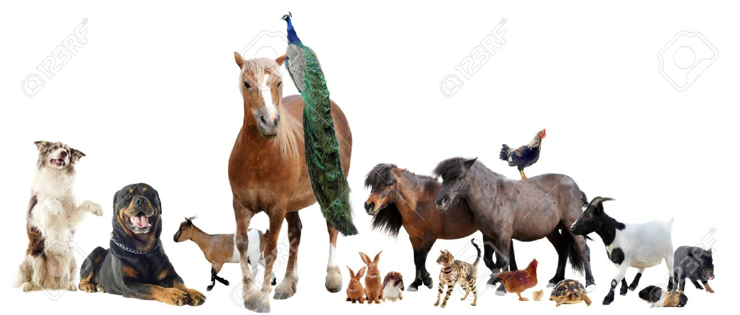

Please note that all homework is optional, although it is expected that your child reads regularly at home.
Reading: If your child reads 4 or more times a week they will be entered into the weekly reading lotto. Each time your child reads, the entry should be signed by a parent and the reading record then handed in on a Friday.
Spellings: Given out on a Friday and tested the following Friday (Year 2 and 3).
Maths: Given out on a Monday and handed in the following Monday (Year 2 and 3).
Abacus Active Learn: Fun maths games tailored to support your child's learning in class. Log in details can be found in the front of your child's reading record.
Topic: Tasks can be chosen and carried out weekly and brought into school to be shared with the class on a Wednesday.

