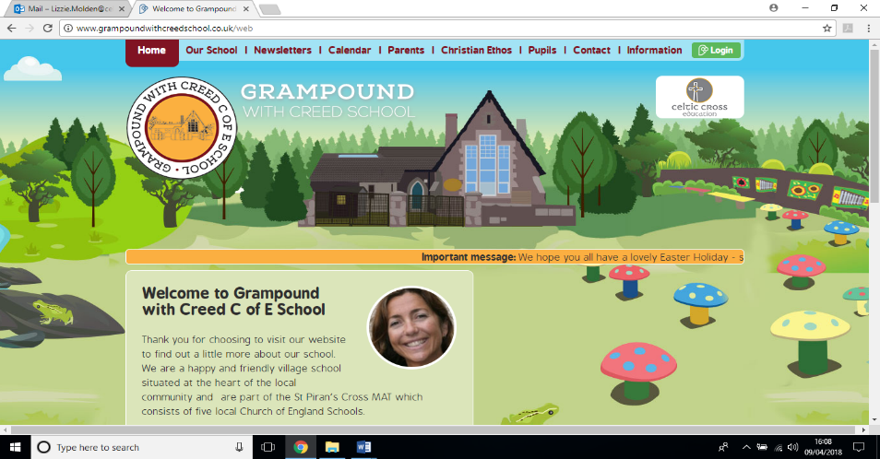

**Carne Class**

**Eat, sleep, grow, repeat!**

**Essential Knowledge / Skills**

By the end of this unit the children will know…

Where animals including humans get their food and that food comes from multiple sources

The value of eating a wide range of foods to stay healthy and support growth 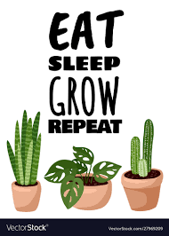

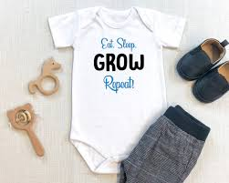

Children can identify and match several animal offspring and their adult forms. They can describe the main characteristics of the offspring found in different animal groups.

Children can describe the main stages of at least two different animal life cycles. They start to compare these life cycles.

Children can identify several ways that animals grow and develop through each life cycle stage.

Children can name the three basic needs of all animals to survive. They can describe the specific needs of a given animal in detail.

Children can describe the effects of exercise and begin to explain the importance of exercise for the human body.

Children can identify several foods according to the basic food groups; can talk about the importance of a balanced diet. They can explain how to be hygienic and why this is important.

Children can sort and classify objects (animals) into simple groups. They use scientific language to talk about their findings. They start, with support, to notice patterns and relationships between the groups.

Children can use simple secondary sources to find answers to a question.

Children can ask simple scientific questions and use scientific language to answer them.

Children use simple secondary sources to find answers and talk about their findings to an audience.

Children can carry out simple practical tests and use their observations and ideas to suggest answers to questions.

Children can carry out simple practical tests, make careful observations and draw simple conclusions.

**Links to Christian values – compassion, perseverance, wisdom**

**Compassion**- We will think deeply about what it feels like to make a mistake or take a bad choice and the consequences of this. We will discuss and practice being compassionate towards one another in good times and bad and how we are learners and we are expected to make mistakes and come back from them with the help of our friends and teachers.

**Perseverance-** We will challenge ourselves physically and mentally and experience what it is like to persevere at a skill over a period. We will monitor and celebrate our progress and reflect on the process and the perseverance it took to get where we are

**SMSC / British values links**

**Democracy-** I can influence my lessons and my experiences in class by sharing my ideas and responding.

**Respect**- I will listen to others, as I would like to be listened to

**Law-** I understand that the school rules mirror society law and must be respected. I learn about choices and consequences through trial and error and through time in with a grown up when I make a mistake

**Responsibility**- I have a responsibility to do the best I can each day and engage in lessons and school life. I am responsible for my own actions.

**Veryan School Topic Plan** 



**Writing**

* Daily Phonics activities to support use of taught graphemes
* Hold a sentence, complete a sentence and unscramble the sentence activities

Documenting the lifecycle of a chicken from observation

Keep an exercise diary

**Reading / Key Texts**

* Olivers Vegetables
* Health and hygiene fact books
* My Garden
* Mary Mary Quite Contrary, How does your Garden Grow ?
* 2x per week reading of scheme reading books and daily book time and storytelling plus a reading for pleasure take home book.

**Computing**

**Graphics**

Use ICT to generate ideas for their work.

Use various tools such as brushes, pens, rubber, stamps, shapes.

Save retrieve and print work.

**PE**

.

**Music**

**Maths - White Rose Coverage**

**Science Week**

**RE Week**

**Art & Design / Design Technology**

* Making food from things we can forage in the wild- Elderflower fritters/ elderflower cordial.
* Wild Garlic butter

**Foundation Subjects**

**History / Geography**

* Hedgerows mini topic Week 1

**Non topic based**

**Eat, Sleep, Grow, Repeat!– Theme Content**

**Core Subjects**

**Applied Maths**

* Days of the week
* Months of the year
* Counting how many are here today
* Snack time orders



**Let’s take a walk on the Wild Side! – National Curriculum & Skills progression**

**Core Subjects**

**Foundation Subjects**

**Writing**

To recognise consonant digraphs which have been taught and the sounds which they represent.

To recognise vowel digraphs which have been taught and the sounds which they represent.

To recognise words with adjacent consonants.

To accurately spell most words containing the 40+ previously taught phonemes and GPCs.

To spell some words in a phonically plausible way, even if sometimes incorrect.

* ‘n’ before ‘k’ (e.g. bank, think);
* dividing words into syllables (e.g. rabbit, carrot);

**Reading / Key Texts**

To apply phonic knowledge and skills as the route to decode words.

To blend sounds in unfamiliar words using the GPCs that they have been taught.

To respond speedily, giving the correct sound to graphemes for all of the 40+ phonemes.

* To read words containing taught GPCs

**Applied Maths**

* I can tell you what day of the week it is
* I can work out practical problems involving division and multiplication for example when sharing fruit and snacks or sharing out resources
* I know what the symbols for division and multiplication mean.

**History / Geography**

* I can identify the natural /wild paces in my local environment
* I can name and identify some features of a local suburban area
* I can identify places in my local area that are significant and /or important to certain groups of people i.e the church,

**Art and Design / Design and Technology**

* Explore, join and use a range of materials to create a planned effect
* I can reflect on my choice of design and materials ad suggest possible changes or improvements

**RE Week**

* I can talk about Christianity as a religion and a belief system.
* I begin to formulate my own opinions and understand that they may differ from other people
* I know that Christians believe God made the world
* I can explain why and demonstrate how we can take care of the natural world

**Science Week**

* I can identify the parts of a plant
* I know what living things need to help them to grow
* I can identify man-made and natural materials and understand why some man- made materials might be harmful to the natural world

**Non Topic Based**

**PE**

Link two or more actions together. Perform some simple dance moves.

 Demonstrate rhythm and control.

Make a sequence.

Agility balance and coordination activities – climb stairs while holding something in 2 hands.

 Balance for short periods on a 2 wheel balance bike, turn and stop with control.

Jump and land on two feet with control. Be aware of the space around me and any obstacles

**Music**

I can identify some musical instruments that I hear

I can describe how a piece of music makes me feel

**Computing**

I can use an age appropriate programme to create pictures and text documents

I can save my work and find, retrieve and print it with the help of adult

**Maths - White Rose Coverage**

Solve one-step problems involving multiplication and division using concrete objects and arrays with the support of the teacher.