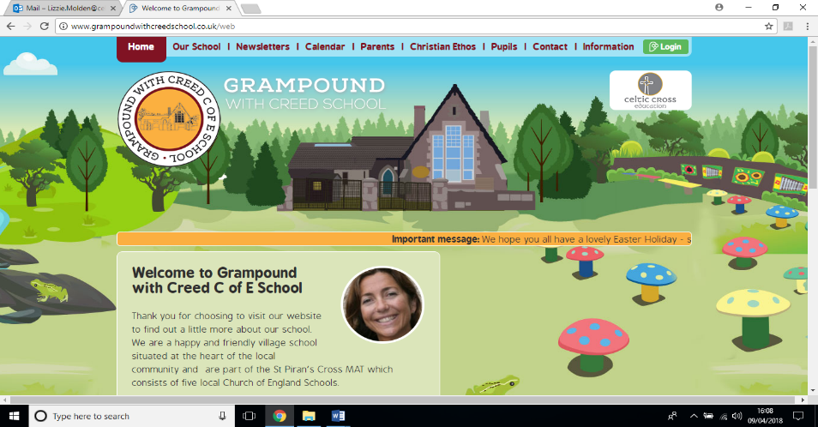

**We are geographers**

**Pendower Class**

**Essential Knowledge / Skills**

By the end of this unit the children will know…

* What is the difference between human and physical features in Geography?
* How do you use a map?
* What can we do to find out more about the geography of our local area?
* RE week - How and why do people try to make the world a better place?
* Science week - How are sounds made?

**Links to Christian values – compassion, perseverance, wisdom**

Compassion

Thinking about how and why people try to make the world a better place? And how we can action this as a class.

Perseverance

Fieldwork can be tricky and you need to be precise and careful to carry out investigations properly. This will take perseverance and resilience to make sure the results we get are valid.

Wisdom

Using what we find out during our fieldwork to draw conclusions and grow our knowledge of the local area in particular.

Using our experiences of carrying out fieldwork to refine our methods and make wiser choices.

**SMSC / British values links**

**British values**

Rule of law – We respect our class rules and the rules that we need to follow when we are out and about in the community.

Mutual Respect – Continued - Focussing on the way that we speak to other people and working together to celebrate each other’s achievements.

Individual Liberty – We can make our own choices about the way that we show our learning and present our findings.

**SMSC**

Spiritual and moral – Asking how and why people try to make the world a better place and trying to do so ourselves.

Social – We will work in teams to carry out investigations.

Cultural – We will be finding out about our culture and heritage.

**Veryan School Topic Plan** 

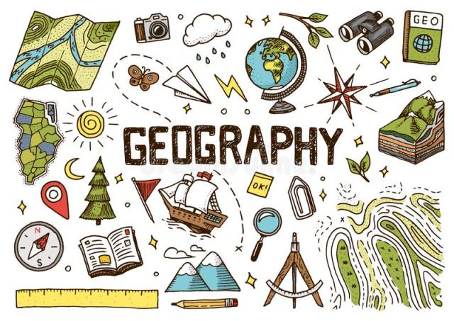



**Science Week – Sound**

* Children will be able to:
* Identify how sounds are made.
* Recognise how vibrations travel through a medium to the ear so that we can hear.
* Understand how pitch and volume change and find patterns in the vibrations produced.
* recognise that sounds get fainter as the distance from the sound source increases

**RE Week - How and why do people try to make the world a better place?**

* Children will be able to:
* Explain how people try to make the world a better place and give examples.
* Say why people try to make the world a better place.
* Talk about what they can do to make the world a better place.
* Carry out actions to make the world a better place.

**Maths**

* Time (Year 2, 3 and 4)
* Measurement – (year 2,3 and 4)
* Recapping the four operations (Year 2, 3 and 4)

**Art & Design / Design Technology**

This term we will be focussing on landscape art to link with our geography theme. We will be using different pencil types to create sketches, natural materials to add texture and colour and exploring shading.

**Geography**

* We will be learning to be Geographers, this will involve fieldwork and practical investigations.
* We will also be learning about the human and physical features of our local area, using maps that have already been made and our own maps that we will make, as well as aerial photographs.
* We will be finding out about grasslands, hedgerows and soil.

**Computing**

Children will be using ICT for mapping purposes.

They will be presenting data collected during our fieldwork using ICT.

**PE**

* Athletics and sports day preparation.
* Orienteering through Geography.

**Writing**

* We will be revising the spelling, punctuation and grammar taught within each year group.
* This term we will be focussing on Cornish stories and poems.
* Children will write their own versions of stories and poems that are traditional to Cornwall.
* They will be inspired by the geographical work that we carry out, to set their stories and poems in the local area.

**Reading / Key Texts**

* **Max and the Millions - Guided Reading**
* **Various Cornish myths and legends and Cornish poetry.**

**Music**

As part of our work in science, we will be learning about pitch and volume and ways that sounds can be made.

We will also be taking part in the end of year show and practising for this.

**Foundation Subjects**

**Non topic based**

**We are geographers – Theme Content**

**Core Subjects**

**Applied Maths**

* During our fieldwork sessions, children will be using Maths, particularly data handling and statistics, to draw conclusions and share their results.



**We are geographers – National Curriculum & Skills progression**

**Core Subjects**

**Foundation Subjects**

**Writing**

* Writes sentences that are sequenced to form a short narrative (real or fictional) (Y2)
* Develops positive attitudes towards, and stamina for, writing, by writing for different purposes. (Y2)
* Make simple additions, revisions and proof-reading corrections to their own writing (Y2)
* Discusses writing similar to that which they are planning to write and understands and learns from its structure, vocabulary and grammar. (Y3 + 4)
* Assesses the effectiveness of their own and others' writing and suggests improvements. (3 + 4)

**Reading / Key Texts**

* **Max and the Millions - Guided Reading**
* **Various Cornish myths and legends and Cornish poetry.**

**Applied Maths**

* Solves simple problems in a practical context. (y2)
* Solves problems that involve Year 3 and 4 mathematical understanding in a practical context.

**History / Geography**

* Year 2 - Use maps, atlases and globes to identify the UK and selected other countries. Use aerial photographs and plan perspectives to recognize landmarks and basic human and physical features. Construct basic maps using symbols in a key.
* Year 3 - Use maps, atlases, globes and digital / computer mapping to locate countries and identify features of the UK. Use four points of a compass. Use aerial photographs. Use fieldwork to support studies.
* Year 4 - Use maps, atlases, globes and digital / computer mapping to locate countries and identify features of Europe. Use symbols and keys (including OS maps). Use fieldwork to support studies.

**Art and Design / Design and Technology**

* Different pencils for different purpose and effects
* Begin to experiment with different tools for line drawing.
* Begin to use a sketchbook for practice and to show development of their own ideas and to explore technique and composition.
* Explore shading with a pencil.
* Create work using natural materials to develop skills on texture.

**RE Week**

* I can identify how religion is expressed in different ways. (2)
* I can make links between beliefs and sources, including religious stories and sacred texts. (3/4)
* I can identify the impact religion has on believers’ lives. (3/4)
* I can describe some forms of religious expression. (3/4)
* I can make links between values and commitments, and my own attitudes and behaviour. (3/4)

**Science Week**

* identify how sounds are made, associating some of them with something vibrating
* recognise that vibrations from sounds travel through a medium to the ear
* find patterns between the pitch of a sound and features of the object that produced it
* find patterns between the volume of a sound and the strength of the vibrations that produced it
* recognise that sounds get fainter as the distance from the sound source increases

**Non Topic Based**

**Computing**

I can use technology to organise and manipulate digital content

*I can use the internet effectively, including search technologies*

*I can collect information and present it to a group or audience*

*I can combine a variety of software to accomplish given goals*

**Music**

Sing in tune, breathe well, pronounce words, change pitch and dynamics.

Sustain a rhythmic ostinato/ drone/ melodic ostinato (riff) (to accompany singing) on an instrument (tempo/ duration/ texture).

Perform with control and awareness of what others are singing/ playing.

Show control in voice and pronounce the words in a song clearly (diction).

**PE**

Y2 - Explore different jump techniques.

Set myself targets to improve my performance.

Y3 - Refine sprint technique.

Improve personal best performances

Y4 - Run over a longer distance, conserving energy to sustain performance

Jump in a number of ways, using a run up if appropriate.

**Maths - White Rose Coverage**

* Time (Year 2, 3 and 4)
* Measurement – (year 2,3 and 4)
* Recapping the four operations (Year 2, 3 and 4)