_______________________________________________________________________________________________________________

Veryan C of E School
Veryan, Truro, Cornwall, TR2 5QA
veryan.secretary@celticcross.education
01872 501431 www.veryanschool.co.uk

Veryan CofE Primary School Information and Welcome Pack.
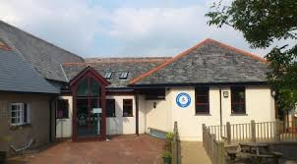
Veryan School is a very special place where we aim to provide an environment in which our pupils enjoy meeting challenges, developing skills and building happy, healthy relationships with those around them.

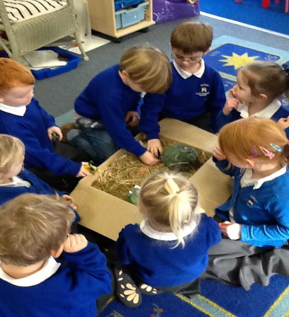
We provide a rich and varied curriculum which inspires our children and helps them to reach their full potential by using a range of teaching styles to meet each individual’s needs. We pride ourselves with the progress made by every child, regardless of ability. As well as becoming more confident in their academic abilities, children also develop their personal qualities, which help them to contribute to the school community and beyond. Welcome to Veryan Church of England School!

In this pack you will find information to help you and your child to settle into our school community. Our school website is updated regularly with individual class pages, School and Trust policies, weekly newsletters and newsfeed bulletins for notifications.
Why not bookmark our website: www.veryanschool.co.uk

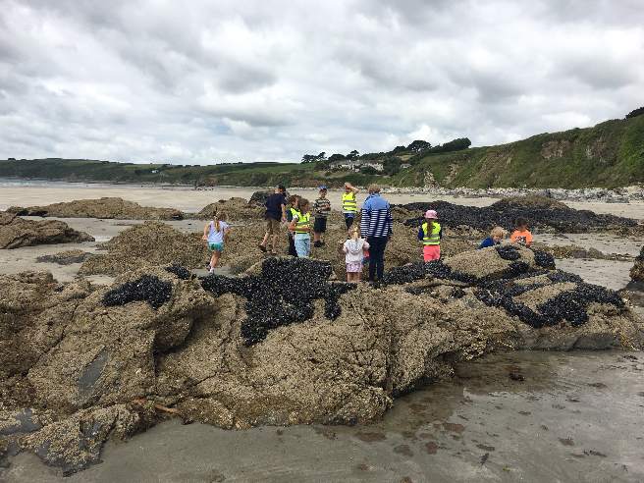
Veryan CofE School is situated in the beautiful village of Veryan on the Roseland Peninsula and has served Veryan and the local villages since 1872. Our school is one of twelve schools that make up Celtic Cross Education. Our Trust website can be found at www.celticcrosseducation.co.uk
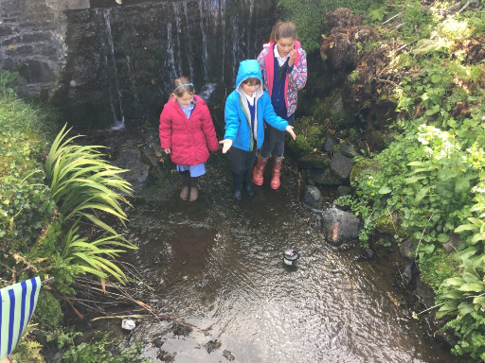
All our Trust schools share in the same core value: ‘We Nurture, We Learn, We Achieve Together. In addition our own School values are Perseverance, Wisdom, Respect, Trust, Forgiveness and Compassion. We encourage our children, staff and volunteers to demonstrate our values every day in their learning, behaviour and attitudes both in and outside of school.
At Veryan School we have excellent links with our local village Church. Every Friday (approx 9:15-9:45am) the whole school take part in collective worship in the Church and have regular special services led by Reverend Philip Greenwaulgh. We are also lucky enough to have regular services led by the ‘Open the Book’ team who tell and act out bible stories to our children and the congregation in a fun, exciting way.

Breakfast Club
We understand that for some parents and carers our 8:30am start may not be suited to those who need to get to work and other commitments and so we offer a breakfast club facility to all our children, where they can come together and enjoy a sociable, healthy breakfast and some quiet play before meeting outside on the playground. There are two available sessions. Session 1 begins at 7:45am and costs £4.00 per session. Session 2 begins at 8:15am and costs £2.50 per session. The sessions are pre-bookable on Parentpay* and must be booked and paid for in advance.

Breakfast Club  (session 1) | 7:45-8.30am
Breakfast Club  (session 2) | 8:15-8.30am
Pupils welcome into the playground with parents/carers | 8.30am
Pupils line up independently and lead into school | 8:45am
Morning registration | 8:50am
Break | 10:30-10:45am
Lunch | 12:00-1:00am
Collective Worship  (Mon-Thurs) | 1:00-1:20am
School ends | 3:15pm
After School Clubs | 3:15-4pm
Below is a general guide to our school day, times are approximate and subject to change depending on the needs of the school.

Break - snack and tuck shop
During our morning break children are welcome to bring a healthy snack (e.g. fruit, yoghurt, cheese) to eat during their playtime. KS1 children will be offered fruit or vegetables free of charge under the government’s School Fruit and Vegetable Scheme. In addition our year 6 children run a ‘tuck shop’ during break time offering small cups of cereal, cereal bars and fruit to purchase for approximately 20-30p each. If your child would like to bring some money for tuck please ensure this is in a clearly labelled wallet/purse or envelope.
We also take weekly deliveries of fresh milk from our supplier Cool Milk. Free milk drinks are made available to all under 5’s and the option to continue to purchase milk for your child once they reach 5 years and over is available if you would like it.

School meals
We are lucky enough at Veryan School to have our own kitchen where fresh, tasty and nutritious meals are cooked and served daily by Caterlink. Meals cost £2.41 and must be booked and paid for on Parentpay* in advance of any meals taken (although we do understand that there are occasional emergencies and the school will be able to assist on these occasions.) A copy of the current menu can be found in the school foyer.
*Book and pay with our cashless school system
Veryan is a cashless school, so any trips, meals and even charity donations can be made via an individual Parentpay account.
When your child starts at Veryan School you will be given a personal Parentpay account with login details which allows you to make payments and bookings securely and conveniently at a time that suits you.
A current menu is displayed on Parentpay for you and your child to make their meal selections for the week/term ahead. Full instructions on how to make bookings and selections as well as how to pay using your Parentpay account can be found at the back of this pack. (Currently children in KS1 receive free school lunches under the Government scheme - ‘Universal Infant School Meals’ these meals, along with children eligible for Free School Meals/Pupil Premium are still bookable on Parentpay in the same way, but payments will not be taken at the point of checkout.)
After School Clubs
We regularly review the After School Clubs we offer at Veryan, but generally they run from 3:15-4pm and incorporate sport, art & crafts, singing and drama and ‘Friday Funhouse.’ Clubs are free of charge with the exception of Friday Club, which is run and organised by the Year 6 children. The Year 6’s use this club to help raise funds for a leaver’s treat at the end of the summer term and to give a leaving gift back to the school in memory of their time with us at Veryan. Friday Club costs 20p for subs each week plus some additional spending money to buy snacks, for cake sales, hot chocolates etc depending on what is planned that week.
Specific club information can be found on the booking page at www.veryan.parentseveningsystem.co.uk
Clubs are usually announced in the school newsletter at the beginning of term, booking is essential on the system mentioned above to ensure we have a register of those attending.

Boys | Girls
White polo t-shirt/shirt | White polo t-shirt/shirt
Black or grey trousers/shorts | Black or grey trousers/shorts/  skirt/pinafore  (Blue & white gingham dress in summer)
Royal blue jumper | Royal blue jumper/cardigan
Black or brown sensible shoes | Black or brown sensible shoes
PE Kit
Black shorts
White t shirt
Plimsolls or trainers
Uniform

We currently have two suppliers that stock our logoed school wear. These are:
- My Clothing
- School Trends
Offering these two stockists gives families the ability to order uniform at a convenient time, without minimum order quantities and straight to school or your own home.
https://myclothing.com/
School Trends: Please visit
https://www.schooltrendsonline.com/uniform/VeryanCofEPrimarySchoolTR25QA where you can find a full range of embroidered uniform with the school logo as well as the ability to purchase other uniform items.

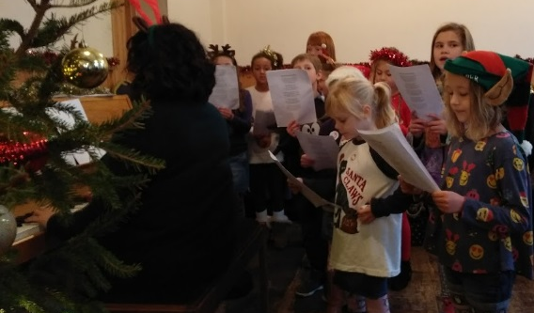
Veryan Parent and Friends Association (PFA)
The PFA has been extremely successful in fundraising for our school. The PFA organises a range of events for the children and families throughout the year. They meet each term to discuss future fundraising events and the purchase of equipment for the school. They have their own email address: veryanschoolpfa@hotmail.com so if you have any ideas or would like to become more involved please email Mrs Sarah Bullen our current Chair of the PFA for more information.

School facilities
Our unique location and historic building means that whilst we do not have a vast school site we do have, and make the most of, our local area. We are fortunate enough to have access to the Veryan Village Hall for indoor PE lessons, Christmas and summer productions and other similar events. The school also owns its own recreational field, which is currently under development, but plans are in place to make use of this space for a variety of outdoor activities and learning opportunities. Veryan Sports and Social Club is just 5 minutes walk and we are able to use this area for our sports day and various other sporting events throughout the year. Carne and Pendower beach are within walking distance of the school and we regularly enjoy whole school beach trips to support our work in school and for end of year treats! Finally, the local pond, woodland walk and park are just on our doorstep and provide another rich learning environment for us to explore.

Our team and class structure
Our school has three main classrooms, one of which can be divided into two smaller classrooms when required, a library, office, staff room and lobby.

We currently have 3 classes:
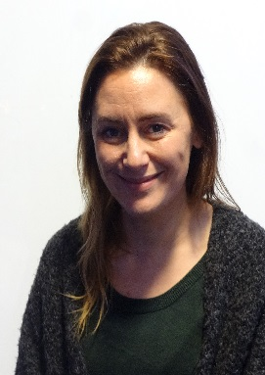
Miss Emeline Goodall is our Carne Class teacher, leading Nursery, Reception and Year1 children. Miss Goodall is supported by teaching assistant, Mrs Sue Hocking.

Miss Goodall

Mrs Hocking
Miss Laura Blayney is our Pendower Class teacher, leading Year 2 and 3 children. Miss Blayney is supported by teaching assistant Mrs Demelza Spears.

Miss Blayney

Mrs Spears

Mrs Sharron Cartwright is our Kiberick Class teacher, teaching years 4-6 supported by teaching assistant Mrs Rachel Hawkins.

Mrs Hawkins

Ms Caroline Jarrett is our Executive Head of School. Ms Jarret leads both Veryan and Grampound with Creed School since April 2019. Ms Jarrett has been a Head of School at Grampound with Creed for five years and teaching for over twenty five years.

We are also supported by Mrs Hester Warburton, who leads the breakfast club sessions, Miss Jazmin Danks and Mr Rory Webb our PE coordinators and Mrs Errin Allan our school secretary.
Rachel Moseley is our SENCo. Mrs Moseley works across several schools within our Trust and regularly visits Veryan School to play an integral part in the coordination of all aspects of Special Educational Needs.
We are also very fortunate to have a number of friends and family of the school who generously give up their time to support the school and volunteer to help with activities, listen to readers and help at lunchtime.

We hope you have found this information useful. Please see overleaf for our Home-School Agreement documents, Parentpay information and our Pupil Data Sheet for the information we require for our computer-based system.

If you have any further questions or queries please do not hesitate to contact the school office on 01872 501431 or email: veryan.secretary@celticcross.education

(N.B. Prices/charges correct from September 2019)

