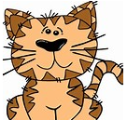
COPY CAT
These questions are all in the text.
- Read the question and highlight key words
- Scan the text for key words
- Re-read to check this matches the question
- Copy the word/ phrase or information

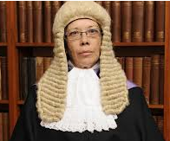
JUDGE AND JURY
These questions want your opinion based on the text
- Scan the text for phrases from the question or the correct section

- Re-read the text so that you have a FULL understanding

- Give your opinion using evidence from the text to support your answer

AUTHORS CRAFT
These questions are about what words the author has used to create effects or why they have written it in a certain way or used certain words.

- Read the text and think of other words that have similar meanings
- Think about the techniques you use in your own writing and why
- NEVER SAY – “ To make it interesting – this is too vague and general. Instead explain why or how it makes it more interesting
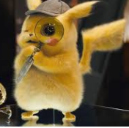
TEXT DETECTIVE
In these questions you need evidence from the text to back-up your answer
- Read the question and highlight key words
- Skim to the section of the text you think it will be in
- Re-read to check you have found the EXACT spot and write your answer
- Then use quotations or reference to the text to support your idea

