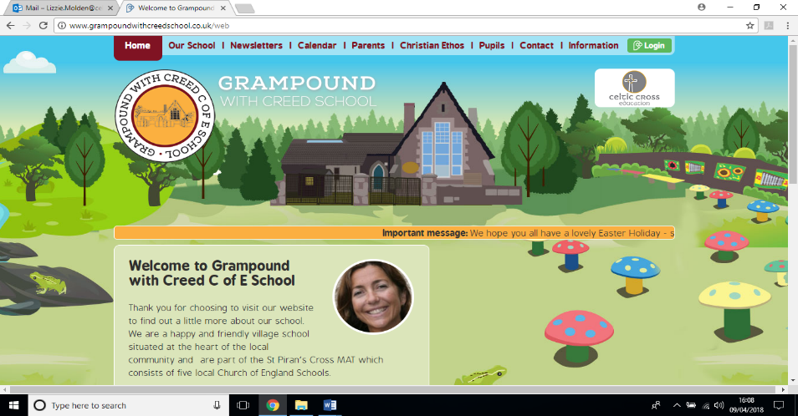

**VERYAN STUDY**

**Kiberick Class**

**Essential Knowledge / Skills**

By the end of this unit the children will know…

* Key historical dates and facts about Veryan
* Key geographical features about the local area
* How Veryan has evolved as a settlement
* How a Cornish hedge is constructed, its importance to heritage and wildlife.
* Some Cornish vocabulary
* How exercise affects the human body
* How faith helps people when life gets hard

**Links to Christian values – compassion, perseverance, wisdom**

**Compassion**

Showing compassion for the smallest organisms in our world that live in the soil and hedgerows. Our RE topic will look at how people cope with hard times, including death, which will call for compassion to those who have lost loved ones.

**Perseverance**

Completing gardening and painting tasks to improve our school environment will require hard work, perseverance and vision. We will consider these themes when we study and visit the Kedroya labyrinth.

**Wisdom**

As we gain greater knowledge about our local area and the smallest organisms that inhabit it we will gain wisdom in how to appreciate and protect it.

**SMSC / British values links**

**Individual Liberty means we have the freedom to make our own choices and do what we want within reason, as long as we stay safe, stay within the law and respect the other British values.**

* Exploring how individual liberty may change as some children make the transition to high school and others become the oldest in school.
* Considering the potential conflict between one person exercising their individual liberty and the impact upon others.
* Developing strategies for showing greater tolerance for individual liberty. Discuss Pride month as a springboard for this.

**Veryan School Topic Plan** 

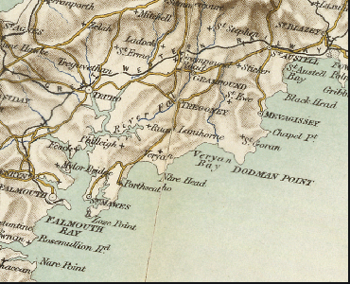



**Geography**

* To observe and identify geographical features of the local environment.
* To effectively use maps to locate places and understand the natural and built landscape.
* Kingfisher Award: Hedgerows; to identify hedging plants and conduct hedgerow surveys, forage from hedgerows.
* To reinstate a school boundary of collapsed hedging with planting and landscaping.
* To visit al of the local places of interest and learn their story and significance.

**Science Week**

* **Year 6 Animals: Recognise the impact of diet, exercise, drugs and lifestyle on the way their bodies function**
* Measuring heart rate before, during and after exercise. Monitoring this over time as they prepare for sports day.
* Monitoring enhanced physical performance through exercise and the use of drugs.
* Observe other changes and responses in their bodies during exercise – sweat, pulse, veins and arteries more prominent etc.
* Audit their own life style and diet and discuss how this affects the body.

**Computing : Presentation and Blogs**

Create power points that capture the learning and discoveries in our studies of hedgerows and soil to present to apply for the Kingfisher Award.

Establish a class blog !

**RE Week**

**Unit U2.12 How does faith help people when life gets hard ?**

Establish that hard in this context are events of the magnitude of death, family splits, illness, loss of income or home.

Examine how Christians and other faiths would respond to this by prayer and drawing on the religious community help through local congregations etc.. Explore how faiths deal with death: beliefs, rituals and ceremonies.

**Art & Design / Design Technology**

* Creating props and scenery for the end of year production: Midsummer Night’s Dream
* Landscape drawing using a range of pencils, pastels and charcoal.
* Analyse religious art – representations of the after life.

**MFL**

French: Vocabulary around houses, homes and families. Building to be able to have a simple conversation using whole sentences about these topics in French and in writing. Whilst also repeating previous vocabulary.

**Maths - White Rose Coverage**

Percentages, Revise and extend Measures

Volume

Problem solving

Y6- Ratio and probability

**PE**

Dance – Work with the specialist dance coach: Katie Bell. composing dance routines. Street dance. Perform at the end of year production

Sailing for 15 children

Athletics and sports day

**Writing**

* Write diaries from perspective of characters in Midsummer Night’s Dream.
* Write a ballad.
* Write newspaper reports
* Present historical information in an attractive and interesting way.
* Examine the difference in language between blogs and other writing, such as their formal Kingfisher Award presentations.
* Spelling: continuing the very successful approach of using topic related vocabulary for weekly spelling ‘exercises’
* Spelling: using apostrophes for contraction and possession.

**Reading / Key Texts**

* **Midsummer Night’s Dream - Shakespeare**
* **The Lady of Shallot**
* **FArTHER by Graham Baker Smith (exploring death, loss and dreams)**
* **Local history texts and pamphlets, original historical source information.**

**Music**

Singing songs from memory – Cornish heritage songs ‘This is my Cornwall’ and ‘Trelawney’

Singing songs for the end of year performance

**Foundation Subjects**

**Non topic based**

**A local study of Veryan – Theme Content**

**Core Subjects**

**Applied Maths**

We have a focus of creating our very own Garden of Eden in the middle playground. This will involve lots of measuring, planning, plotting and calculations, involving area and capacity.

In addition, we will be including problem solving in each week of work to constantly improve these skills.



**South America – National Curriculum & Skills progression**

**Core Subjects**

**Foundation Subjects**

**Writing**

* recognising vocabulary and structures that are appropriate for formal speech
* and writing, including subjunctive forms
* using passive verbs to affect the presentation of information in a sentence
* using the perfect form of verbs to mark relationships of time and cause
* using expanded noun phrases to convey complicated information concisely
* using modal verbs or adverbs to indicate degrees of possibility convey complicated information concisely
* ▪ using modal verbs or adverbs to indicate degrees of possibility

**Reading / Key Texts**

* identifying and discussing themes and conventions in and across a wide range of writing
* making comparisons within and across books
* learning a wider range of poetry by heart
* preparing poems and plays to read aloud and to perform, showing understanding through intonation and expression.
* understanding through intonation, tone and volume so that the meaning is clear
* to an audience

**Applied Maths**

* Pupils connect conversion (for example, from kilometres to miles) to a graphical representation as preparation for understanding linear/proportional graphs.
* They know approximate conversions and are able to tell if an answer is sensible

**History / Geography**

Geographical skills and fieldwork

▪ use maps, atlases, globes and digital/computer mapping to locate countries and

describe features studied

▪ use the eight points of a compass, four and six-figure grid references, symbols and key (including the use of Ordnance Survey maps) to build their knowledge of the United Kingdom

▪ use fieldwork to observe, measure, record and present the human and physical

features in the local area using a range of methods, including sketch maps, plans and graphs, and digital technologies

**Art and Design / Design and Technology**

* Pupils should be taught to develop their techniques, including their control and their use of materials, with creativity, experimentation and an increasing awareness of different kinds of art, craft and design.
* to improve their mastery of art and design techniques, including drawing, painting, sculpture ( if time) …with a range of materials [for example, pencil, charcoal, paint, clay]

**RE Week**

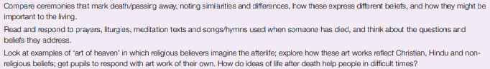

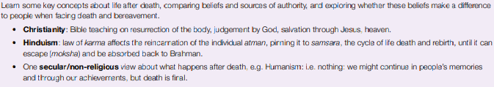

**Science Week**

* Pupils should learn how to keep their bodies healthy and how their bodies might be
* damaged – including how some drugs and other substances can be harmful to the
* human body.
* Pupils might work scientifically by: exploring the work of scientists and scientific research about the relationship between diet, exercise, drugs, lifestyle and health.

**Non Topic Based**

**Computing**

**Presentation**

Work independently to create a multi slide presentation that includes speaker’s notes.

Use transitions and animations to improve the quality of the presentation.

Include sounds and moving graphics in the slides.

Present to a large group or class using the note made.

Blogging

Register for a blog, select a URL and navigate to their blog once it is created.

**MFL**

* engage in conversations; ask and answer questions; express opinions and respond to those of others; seek clarification and help*
* speak in sentences, using familiar vocabulary, phrases and basic language structures

**PE**

Sailing for 15 children.

Athletics

Sports Day

Dance movements and routines for end of year production

**Music**

Sing or play from memory with confidence.

Take turns to lead a group.

Maintain own part in a round/ sing a harmony/ play accurately with awareness of what others are playing.

Perform in live contexts, accounting for musical dimensions.