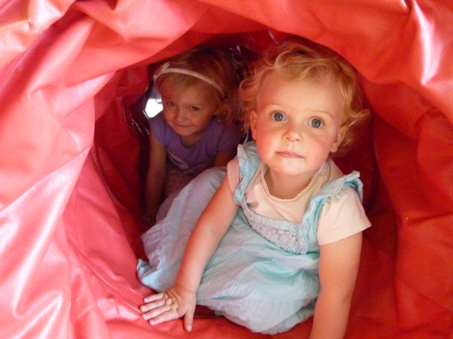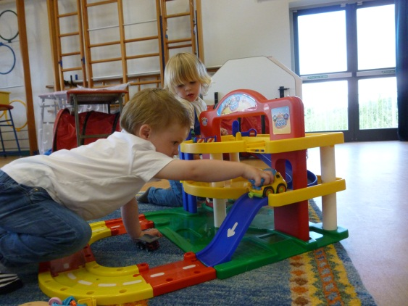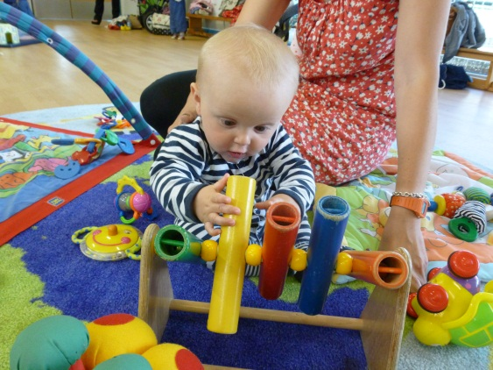

**Truro Nursery School in partnership with TRLC and Veryan School**

Stay and Play Together Sessions

Thursday 1.15pm -2.45pm

Veryan School

Welcoming new families. Please come along and join in with, small world play, sensory and tactile play, song time and other exciting activities.

Play and Early Learning sessions for families following the Early Years Foundation Stage Curriculum

£3 per family (up to 2 children)

0 – 5 years old

For more information: 01872 274693

**First session free of charge**

# thank you